Foundations and background of Ultrasonic Metallurgy

Mechanical properties of solid metals can be changed and optimized when we make ultrasonic processing of metals in a liquid phase. There are two principal modifications after ultrasonic processing, such as porosity reduction and grain refinement (or creation of fine and uniform microcrystalline metal structure).

Let us start with generally applicable comments regarding ultrasonic processing of liquids, such as:

- All (acoustically linear) liquids, single and multi-phase liquid solutions, simple and composite liquid mixtures on low and moderate temperatures, including liquid metals on temperatures being not very close to solidification temperature, behave on a similar way regarding acoustic, mechanical, and ultrasonic vibrations, cavitation, degassing and micro-crystallization.

Cavitation in liquids is the most significant phenomena (or micro physical laboratory) responsible for realizing, or facilitating all Sonochemistry and Ultrasonic Metallurgy related effects, applications, and technologies. Cavitation (a well-known phenomenon during the propagation of high frequency ultrasonic waves in liquids and melts) begins with tiny discontinuities or cavities in liquids followed by their growth, pulsation, and collapse. Cavities result from the tensile stress produced by an acoustic wave in the rarefaction phase. The rate of cavity collapse can be so high that it produces a hydraulic shock wave with pressure reaching tens of thousands of MPa, and locally, cavitation bubbles collapse can produce more than 5000°C. Behaviors and motion of cavities are determined both by properties of the processed liquid and applied ultrasound field. Pulsating effects of cavitating bubbles can increase bubble sizes due to a gas diffusion from a surrounding liquid, even if initially created bubbles are not saturated with any gas (e.g., we have a penetration of hydrogen, in case of molten aluminum alloy). Here, the most important role is played by the oscillations of cavitation bubbles in the acoustic field, while ultrasonic cavitation plays the supportive role in intensifying the bubble formation and in acceleration of bubble/liquid interfacial diffusion.

We also apply the same mathematical models to describe all kind of vibrations, oscillations, and waves in different fluids. Exceptions are liquids behaving as acoustically or mechanically non-linear, and/or anisotropic, such as "biologically-charged liquids", sea water with salts, minerals, and biological-ingredients, high viscosity, and high-density liquids... Clean water and most of liquid metal alloys (within a temperature range sufficiently higher than relevant solidification temperatures) dominantly behave as acoustically or mechanically linear materials (until certain maximal temperature). If we consider M. Planck, Black Body electromagnetic radiation as an "external radiation" (radiating from a black-body cavity towards surrounding, external, and empty space), then we could analogically understand and conceptualize effects within heated liquids, as being influenced by an "internal black-body radiation". Here are grounds for opening a research chapter related to extended thermodynamics applicable to all fluids.

- Ultrasonic and acoustic vibrations in liquids manifest very much like heat-transfer, or thermal, thermodynamic activity of atoms and molecules in fluids. Both are creating mechanical oscillations and associated heat-related effects in fluids. The difference is that an ordinary (non-ultrasonic) heating source produces spatially chaotic, randomized, non-isotropic and non-laminar heating-related motions and radiations (of atoms, molecules, and other small particles). Ultrasonic sources, transducers and sonotrodes, usually produce certain structurally and spatially organized flow of mechanically vibrating and radiating energy (including thermal energy). Vibrating Energy of both, thermal and ultrasonic waves, and associated radiations can be measured using the same family of "heat flow sensors" (for instance sensors based on Peltier effect), showing that ultrasonic and thermal energy are the same. This is also the reason why ordinary heating (or thermal activity and associated radiation) strongly interferes with ultrasonic waves.

- For instance, let us consider ultrasonically agitated liquid aluminum with a certain sonotrode or ultrasonic radiator. During such ultrasonic processing, the sonotrode must be in a direct contact with a liquid metal, since ultrasonic waves are stress waves, which can only exist and transmit between the masses in physical contact. Liquid aluminum analogically (and acoustically) behaves like water on a room temperature. This is the reason why we often use water as the liquid-aluminum acoustic-load simulator, or as testing liquid (since it has similar acoustic impedance and viscosity like water on a room temperature, and its density is also in the same order of magnitude as water, or 2.7 times higher…). Furthermore, cavitation phenomena in molten metals are difficult for studying due to their temperatures, opaqueness, etc. When we realize a well-operating ultrasonic regime in water (using ultrasonic radiators, emitters, sonotrodes and systems designed for ultrasonic liquid aluminum processing), we will have a very similar operating regime like ultrasonically treating a liquid aluminum (with the same tools/emitters/radiators/sonotrodes). Of course, this is valid only if a liquid aluminum is on temperatures sufficiently higher than solidification temperature (for instance, higher for 30, or 50, or 100°C). If liquid aluminum is cooled and approaching closer to its solidification temperature (TL +5 to +10 ºC), its density, viscosity, and other fluids-related properties, including acoustic impedance, will significantly change, and we will have not very good acoustic coupling with implemented sonotrode/radiator/emitter…, as it was before in a very fluidic, water-similar phase. In fact, by cooling liquids, acoustic waves attenuation could increase, cavitation will decrease, and applied vibrating tools will gradually stop oscillating (since acoustic load impedance will change significantly). This is related to the fact that ultrasonically produced degassing is much stronger when liquid aluminum is very fluidic on certain conveniently high temperature.

Cavitation in a liquid metal modifies the applied/absorbed binomial acoustic power due to changes in the medium. Cavitation affects liquid density and velocity, and this affects ultrasound propagation in the medium. However, in a liquid with developed cavitation (several seconds after starting the source of acoustic energy), the efficiency of degassing rises.

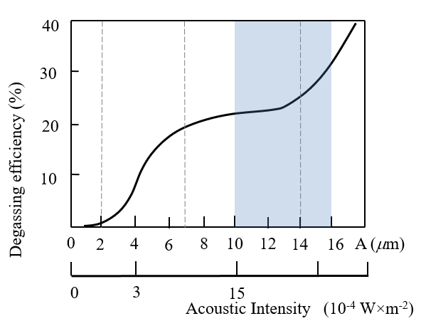

The propagation of elastic vibrations in a liquid containing gas bubbles (originated from cavitation) is accompanied with an additional attenuation related to an energy loss, because of gas heating in oscillating bubbles and subsequent transfer of this heat to a liquid. Elastic attenuation of vibrations is also influenced by scattering acoustic energy from cavitating bubbles and an energy loss caused by acoustic streaming.

When melt temperature starts decreasing, ultrasonic degassing will also decrease, and this way we create conditions for increasing acoustic (or ultrasonic) micro-crystallization (of course, this about increased crystallization, or creation of very fine grains, works better around added impurities such as master alloys particles, when being combined with vibrations and acoustically created nuclei of crystallization. Acoustically induced micro and nano crystallization is also (analogically) applicable to all other liquid solutions, including metal alloys on low and moderate temperatures.

- The well-known Ultrasonic Cleaning technology and most Sonochemistry applications (analogically, acoustically and by design, or by ways of implementation) are like applying ultrasound in liquid metal processing. Of course, operating temperatures and applied ultrasonic resonators are different, but most of phenomenology and manifestations are analogically comparable. Consequently, we can understand Sonometallurgy (or Ultrasonic Metallurgy) as the subdomain of Sonochemistry (including Ultrasonic Cleaning). Everything known in Sonochemistry could be considered as indicative and analogical, intuitive, and brainstorming grounds for expectations that similar effects will be discovered in Sonometallurgy.

- Now, let us address the mutual dependence and interferences of liquid temperatures and acoustic or ultrasonic agitation.

- For instance, we start sonication when a certain liquid is close to solidification at a sufficiently low temperature. For water, at a temperature close to +2°C, (while treated water is still fluidic), when externally introduced sonication starts, we will produce almost immediate and total micro-crystallization and freezing, spreading allover sonicated water mass. It is very similar to what is happening in liquid metals (where relevant and comparable temperatures are shifted up).

- Now, let us imagine that we start heating and/or sonicating water (since what is happening in water would indicate what could happen in a liquid aluminum). This way, kinetic energy and randomly distributed velocities of involved molecules is increasing. Mobility of water molecules is proportionally increasing with increased temperature and overall acoustic activity, cavitation and degassing are also increasing until approx. 60°C, following certain parabolic or bell-curve, which is associated on a Black-Body radiation curve. The maximum acoustic activity and cavitation in water is known to be around 60°. Increasing water temperature higher than 60°C will start reducing ultrasonic activity and cavitation in water… We will also have similar effects for other liquids, but "maximal acoustic activity temperatures" will be differently shifted (again following parabolic or bell-shaped curves). That means, if the liquid aluminum temperature is still within the rising zone of its acoustic-efficiency characterized by certain parabolic or bell-curve-shaped function, acoustic activity and cavitation will also increase until certain temperature maximum, and at the same time we will produce good degassing and cavitation effects. Analogically concluding, if we continue increasing liquid temperature (passing mentioned bell curve maximum-activity zone), cavitation, and ultrasonic activity would start decreasing (if such analogy is valid for all liquids).

- All of that (regarding acoustic activity) is analogically valid for all “linearly behaving liquids”. Organic liquids and sea salt water behave as non-linear liquids, but most liquid metal alloys and composites behave like acoustically linear liquids (in described temperature interval). Practically (when applied on metallurgy), ultrasonic activity in liquids, in proper conditions is beneficial for reducing fluidic friction, and for significant increase of the metal flow during casting, or also and analogically valid is that ultrasonic vibrations can be very much beneficial for extrusion and wires and tubes drawing technologies.

Degassing and Porosity in aluminum alloys

The formation of porosity during and after solidification in aluminum alloys is one of the main defects that negatively impact mechanical properties. Dominant porosity comes from dissolved hydrogen, which is the only gas with significant solubility in molten aluminum.

Four stages of hydrogen precipitation during solidification can be specified as:
Stage 1: diffusion of hydrogen atoms within the molten pool,
Stage 2: formation of sub-critical nuclei as a function of time and cooling,
Stage 3: random emergence of stable precipitates that exceed the critical size required for sustained growth.
Stage 4: sustained growth, as long as dissolved hydrogen atoms remain free, being able to diffuse into precipitated bubbles.

At the solidification point, a significant drop in hydrogen solubility occurs, leading to hydrogen precipitation and development of gaseous porosities. For this reason, the hydrogen content in a molten alloy must be kept as low as possible, especially when dealing with high-strength casting alloys. Several non-ultrasonic methods are usually used to reduce the hydrogen content in aluminum melts, all generating great amount of slag, and presenting a meaningful environmental impact.

Ultrasonic degassing is a possible and reliable way to overtake such drawbacks and to improve hydrogen removal.

Concerning degassing of liquid metals (for instance, aluminum alloys), the relationship between the efficiency of degassing is quantified by the concentration of hydrogen dissolved in the liquid metal, measured in terms of hydrogen mass density (kg/dm³), and processing time (as presented on the picture below).

Such approach to ultrasonic activity is more representative to quantify the quality of the melt. The following figure presents the dynamics (temporal evolution) of hydrogen content in (5 kg) molten A380 alloy treated by ultrasound based on the MMM technology, at 700 ºC.

According to the results, it is suggested that the dynamics of degassing by ultrasound is independent of the initial concentration of dissolved hydrogen in the bath.

The figure below shows the comparison of degassing efficiency between ultrasound (using MMM technology) and argon techniques (A380 alloy, 5 kg, 700 ºC).

where, Trial #1 represents hydrogen removal using chlorine salts; Trial #2 hydrogen removal using ultrasonic technology; Trial #3 using vacuum system; and Trial #4 combining of ultrasound and vacuum in a bath of A356 alloy with 10 kg charge.

- For instance, analogically, we could also speculate, that for Rheocasting of metal alloys, it would be sufficient only to touch (in several points, during a very short time interval), treated semi-liquid metal mass, and this would produce fast and total micro-crystallization (what remains to be verified experimentally).

- Liquids are also manifesting "structural or spatial memory effects" when being acoustically or ultrasonically (also electromagnetically) agitated. For instance, when after ultrasonic processing of liquid aluminum and magnesium alloys, we stop ultrasonic processing, there is still active certain residual decay process (lasting at least several minutes, until 30 minutes) when liquid metal is (internally) acoustically active and shows beneficial properties for casting.

- Now, to say something about sonicating and oscillating amplitudes of ultrasonic energy sources/sonotrodes/tools... Ultrasonic or acoustic energy is directly proportional to the contact surface between liquid under processing and applied or submersed ultrasonic source/tool/sonotrode/radiator/emitter (here, all mentioned terms are synonyms). A submersible ultrasonic transducer is what we consider as ultrasonic waves emitter/radiator/sonotrode…, which will be immersed in a certain liquid (this way, we vibrate liquid from inside). For instance, in ultrasonic cleaning and Sonochemistry applications we often apply ultrasonic agitation from inside or outside (using different ultrasonic transducers). That means, to produce and transfer maximal ultrasonic energy, we need to realize maximal as possible contact surface (what is analogical to electromagnetic waves emitters, antennas, receivers…). In addition, if we increase amplitudes of applied ultrasonic waves, we will also increase acoustic or ultrasonic energy emission (until reaching certain maximal oscillating amplitude of ultrasonic source). If we continue increasing amplitude of oscillations, we will start braking molecular, cohesion, adhesion and Van der Vaals forces between ultrasonic emitter and a surrounding liquid state and an empty gaseous zone will be created between ultrasonic source and a liquid mass. High amplitudes agitation of sonicated liquids will gradually produce time-evolving non-linear acoustic effects (coming closer to plastic deformation effects). This is creating acoustic decoupling (meaning that ultrasonic energy transfer will be significantly attenuated and in certain point stop).

- Most of ultrasonic liquid processing applications can be characterized by ultrasonic processing power, and by a total ultrasonic energy that would be delivered to certain liquid (including liquid metals). Delivered energy is calculated by actual operating power multiplied with a time or integrated during certain operating time interval. This way we can establish necessary technological parameters for realizing different liquid processing.

- Regarding ultrasonic power, we define or specify ultrasonic and volumetric power density in units "Watts/Liter" or W/l. In case of using focused ultrasonic "torch" or "jet" sources or sonotrodes, we define radiated surface power density in "Watts/contact-emitting-surface", or W/cm².

- What is beneficial for ultrasonic liquid processing is to make sonication by sending periodical ultrasonic pulse trains (with defined ON and OFF time intervals), this way involving relaxation, or OFF time intervals, for enabling transient and time-evolving processes to happen between ON periods.

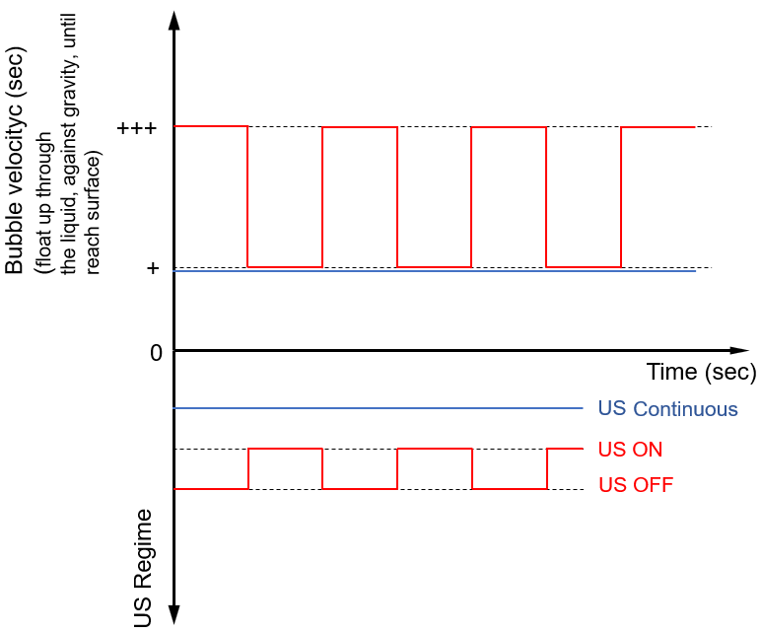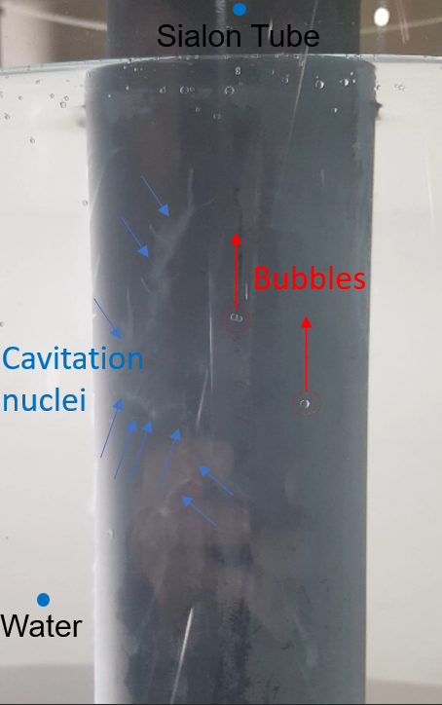

As acoustic cavitation progresses with time, adjacent bubbles touch and coalesce, growing to a size sufficient to allow them to rise through the liquid, against gravity, until they reach the surface. The bubbles rise up faster in an ON/OFF regime mode (OFF periods).

- In addition, we can produce spatially uniform and frequency-wideband ultrasonic field and maximize ultrasonic activity in liquids, if we apply different frequency and amplitude modulating techniques on ultrasonic signals (what is known as MMM technology). MMM technology also means that by applying complex acoustic vibrations, we can make an artificial conditioning of liquid properties. For instance, material properties (including liquids and solid masses), being on certain stable temperature, can be characterized with number of lumped or fixed parameters and constants. When we apply complex-acoustic-field of MMM ultrasonic vibrations, mentioned lumped or fixed and constant-values parameters will spread or transform to some new, "by-intervals-defined parameters". See more about MMM technology here: https://www.mpi-ultrasonics.com/content/mmm-ultrasonics .

- Also, beneficial for ultrasonic liquid processing is to apply certain macro-mechanical motion of ultrasonic source during sonication (for instance circular motion), this way making "spatial sweeping" and processing a bigger liquid mass. This is generating "spatially and by frequency modulated quantity of motion, or modulation of linear mechanical moments" of involved participants.

Looks like that (until present) nobody integrally formulated such simple, analogical, generally valid (for all liquids) conclusions in one place, related to ultrasonic liquid processing, or to ultrasonic energy transfer, degassing, cavitation, influence of operating temperatures, acoustic coupling, and decoupling between ultrasonic sonotrodes and treated liquids, linear and non-linear behaviors of liquids during ultrasonic processing ... This, what is summarized here, is essential for understanding Sonochemistry and Ultrasonically assisted Metallurgy, or Sonometallurgy … Without knowing considerations and facts, as here summarized, we will not have a basic conceptual understanding about what is happening during ultrasonic processing of liquids (including liquid metals), and we will struggle with explaining multi-parameter and time evolving processes. Of course, all that what exposed here, is separately and sporadically known until certain level, and on some incomplete way stated or published, but nobody made such generally valid and mutually related comments and conclusions, integrally formulated in one place. We need to address such problematic much better and systematically …

This what is briefly elaborated here is our competitive advantage regarding understanding Ultrasonic Metallurgy.

Maybe it is still not recommendable to explain what we are doing (and what the relevant background behind all of that is), before we create something much more substantial …

RESUME

- MMM what is it? Basic description of the process

MMM technology (or Multifrequency, Multimode, Modulated sonic and ultrasonic agitation) is the methodology how to vibrate, almost spatially uniformly, arbitrary shaped masses, without creating standing waves. MMM technology creates temporally and spatially variable or oscillatory, linear, and angular moments of involved moving participants. When we have temporal and spatial variations, oscillations, and gradients of mechanical (and electromagnetic) moments, this is producing different forces and currents. Forces acting on certain distance are producing energy, and power during certain time is also energy... Mentioned spatial and temporal, oscillatory forces, and moments' gradients, are producing streaming, jet effects, and cavitation in liquids, and cavitation is producing wide range of sonochemical effects ... At the same time with MMM signal processing, we realize synchronous excitation of many natural, resonant modes, by modulating operating frequency and signal amplitude of sonic and ultrasonic waves, both in a high and low frequency domain. This way, we create non-stationary, repetitive, dynamic, and variable excitation of different natural resonant modes of certain body (in our case we agitate liquids, or liquid metals). This is producing effects of degassing, grain refinement, cavitation, homogenization, capillary penetration and deep wetting and coating of different particles being submersed in the same liquid metal state. Nonstationary acoustical excitation (without standing waves creation) is much more effective, regarding energy and mechanical moments exchanges, compared to fixed and stable ultrasonic frequency processing of liquids. MMM technology and related equipment design still has its (acoustic, mechanical, or ultrasonic) limits, but anyway there is an exact design and optimization methodology (practiced by MPI) leading to good ultrasonic processing tools.

Please, read more about matter waves, oscillations, vibrations… here:
https://mastersonics.com/documents/revision_of_the_particle-wave_dualism.pdf
www.UltrasonicMetallurgy.com
www.MPI-Ultrasonics.com
www.Mastersonics.com

(2) What have we done with Al and Mg alloys?: degassing, grain refinement, alloy modification, etc.

Degassing:

Density index lower 1% in processing time 3 time faster than usual traditional degasser methodologies (argon, fluxes, etc.).

Alloy A380 (AlSi9Cu3)
Temperature of degassing 700 ºC

Fixed Frequency ultrasonic processing (competitors)
0 minutes | 3 minutes
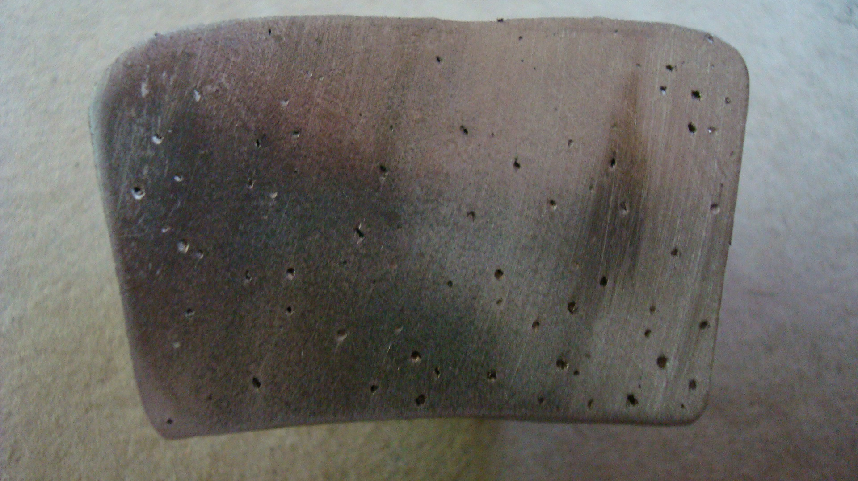 | 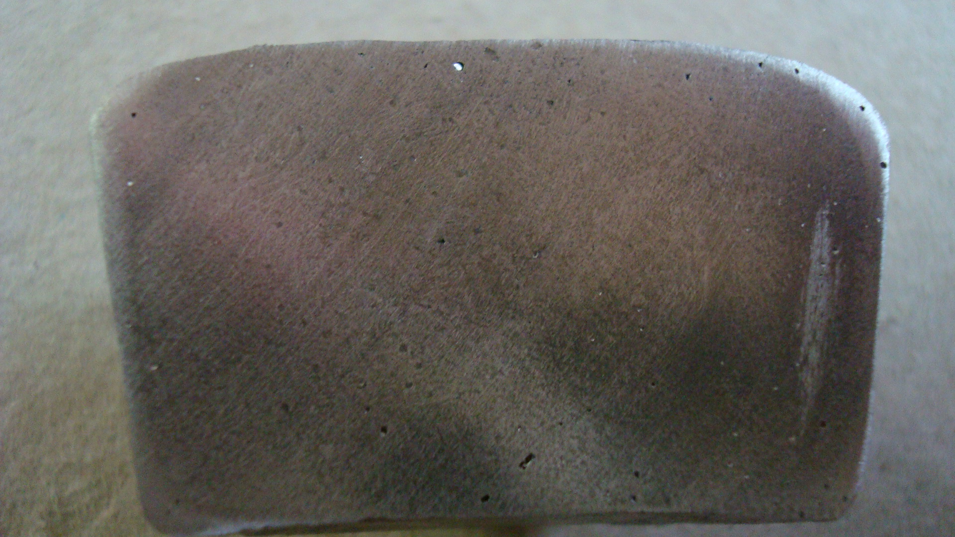

MMM Technology
0 minutes | 3 minutes
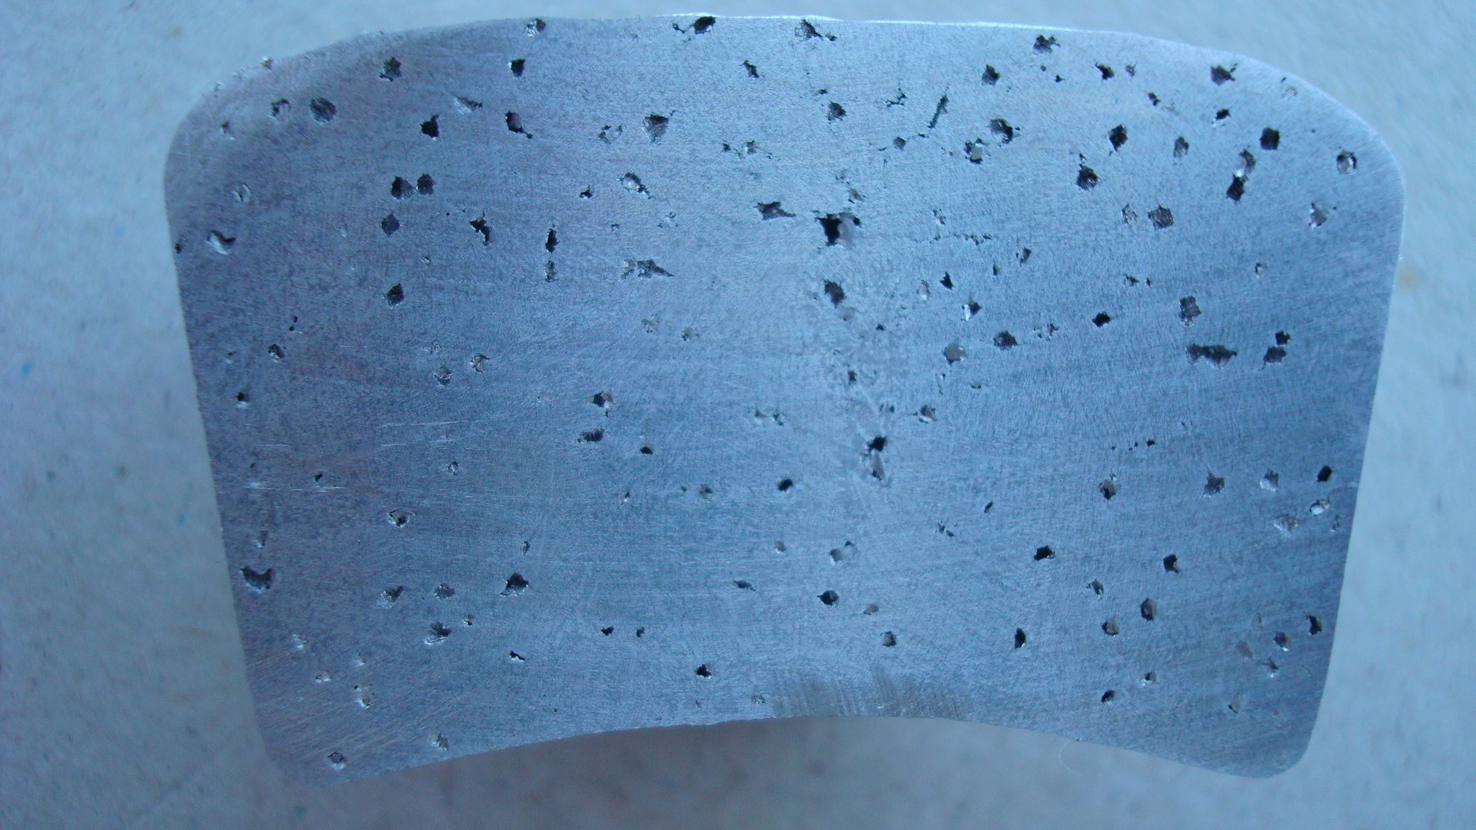 | 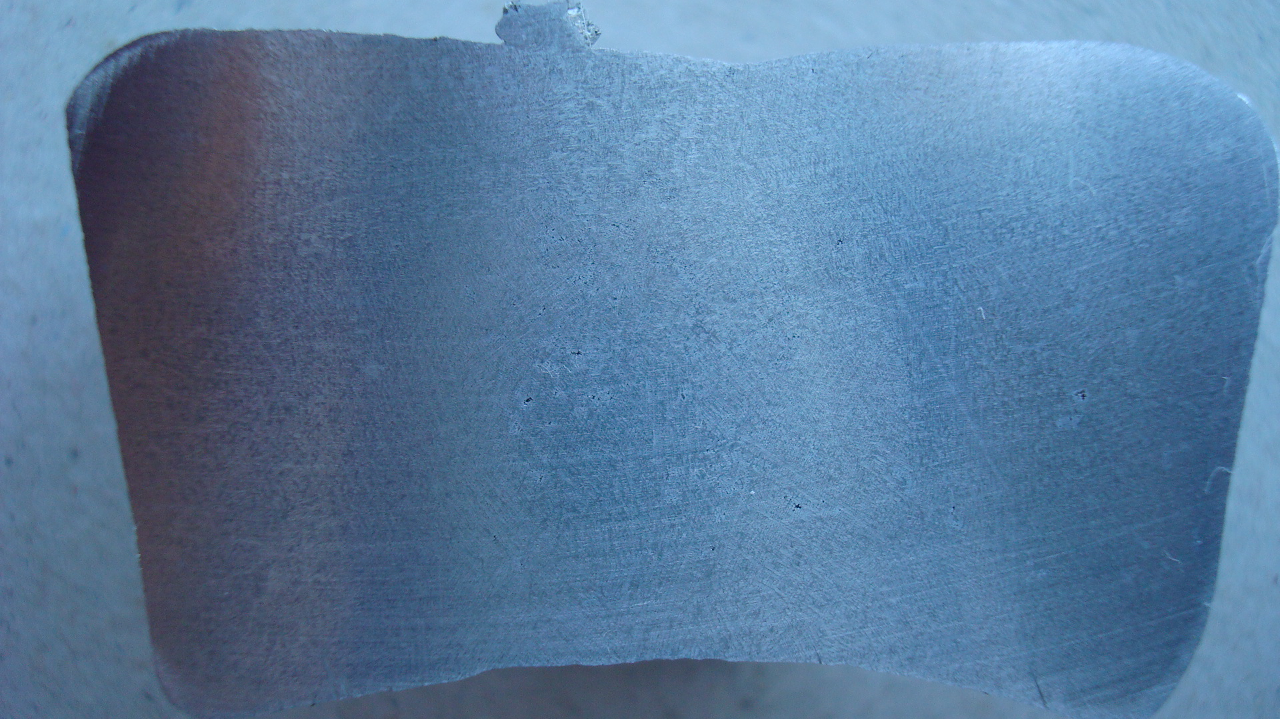

The ultrasonic degassing is based on the cavitation mechanism promoting the nucleation of bubbles inside of molten metal at a range of temperature, which will cause coalescence and rise to the surface of the met carrying with it the dissolved hydrogen as non-metallic material present inside. However, the formation of cavitation, besides other properties of ultrasound, is determined by the liquid's properties, thus requiring the existence of nuclei activation. It is known that the presence of nuclei activation substantially reduces a minimum value of the cavitation pressure (p_{c}) necessary for bubbles formation. Furthermore, by increasing time of treatment and consequent cleaning of the molten metal, nuclei activation tends to decrease, making it difficult to remove the remaining hydrogen. Such evidence is more problematic for traditional degassing methods than for MMM technology due to its capabilities for distributing thin and dispersing bubbles evenly throughout the volume of the molten metal.

Although the mechanism for removing hydrogen dissolved in the molten metal is similar for both degassing techniques (diffusion of hydrogen atoms into the bubbles, and removal of bubbles and removal to the bath surface), the degassing rate in the ultrasonic treatment is much higher. This behavior stems from the cavitated bubbles being much larger in number and much better distributed in the baths than the argon bubbles introduced under pressure. On the other hand, the cavitation mechanism promotes the formation of acoustic flows, which intensify the diffusion mechanisms, namely the transport of hydrogen atoms to the vicinity of the formed bubbles.

The combined effect of these two factors is responsible for the higher removal rate of hydrogen, and density increase, during the ultrasonic degassing process, compared to the rates achieved by applying argon degassing.

Degassing by argon injection into the molten metal through a rotary diffuser is a well-established technique in the aluminum alloy casting industry, although its efficiency is always dependent on long treatment times. Typically, time of the order of 12 to 30 minutes (depending on volume and temperature, diffuser characteristics, among other factors) are required to obtain hydrogen concentrations within the usual permissible values. However, with the increase of treatment time and rotary velocity, there is a substantial increase in slag production due to the turbulence created during the process. The turbulence generated tends to break the oxide film formed, forming new aluminum oxide by chemical reaction with the oxygen in the atmosphere, and so continuously throughout the processing time.

The surface oxide film formed on the liquid metal of an aluminum alloy acts as a protector from oxidation and hydrogen absorption by the rest of molten metal. Therefore, the oxide film is beneficial if it remains on the surface of the melt. When it is introduced inside molten metal, it becomes problematic, giving a rise to numerous non-metallic inclusions deteriorating the mechanical properties of the alloys. The removal of these and other inclusions are carried out simultaneously with degassing process due to the turbulence generated during this process, helping their agglomeration and consequent removal by flotation. The gas removal efficiency depends on the interaction of the involved particles with gas bubbles introduced into the bath, the diffuser's rotation speed, and the generated turbulence. However, while increasing rotation speed facilitates the molten melt clean, it also forms detrimental slag on the surface.

Compared to the argon degassing process, the ultrasonic technique significantly reduces the slag weight resulting from such operation. In fact, according to Table 1, the reduction in slag weight resulting from ultrasonic degassing of AlSi9Cu3 and AlSi7Mg0.6 alloys was 2 and 2.6 % of slag per 1000 kg of molten metal, respectively. This difference proves that the absence of turbulence and conservation of the oxide film on the bath's surface and the processing time during ultrasonic degassing are decisive factors in reducing the weight of slag formed.

Alloy A380 (AlSi9Cu3)
Temperature of degassing 700 ºC

Degassing Technique | Alloy | Density (g/cm³) |  | Treatment Time (min) | Slag (%)
 |  | Initial | Final
Impeller Rotary | AlSi8Cu3 | 2.51 | 2.65 | 9 | 2
Ultrasound |  | 2.44 | 2.68 | 3 | -
Impeller Rotary | AlSi7Mg0.6 | 2.43 | 2.61 | 9 | 2.6
Ultrasound |  | 2.42 | 2.64 | 3 | -

In addition, the flows generated during the cavitation bubbles collapse (acoustic streams) of favor the transport of particles/inclusions to the surface of the bubbles and consequent buoyancy flotation. Thus, and according to micrography present in the figure, it is clear the sanity of the microstructure sample collected from AlSi7Mg0.6 alloy bath with 15 kg, degassed by MMM ultrasonic system at 700 ºC for 3 minutes. Additionally, the figure shows that ultrasonic degassing tends to induce certain grain refinement compared with the usual methodologies applied.

Another aspect that deserves attention is the level of refinement of the alloy. With the application of the sonic and ultrasonic MMM technology, it is possible to "activate" acoustically the liquid and facilitate the refinement of an alloy during the solidification step. Experimental results have been demonstrated that the certain acoustic activity inside the molten melt can remain active from 10 to 15 minutes after stopping ultrasonic processing. In fact, according to the Figures, the samples with ultrasonically treated melt display a moderate grain refinement, showing globular and rosette-like α-Al grains, highlighting some moderate grain refinement promoted by the ultrasonic melt treatment.

Alloy A356 (AlSi7Mg0.6)
Temperature of degassing 700 ºC

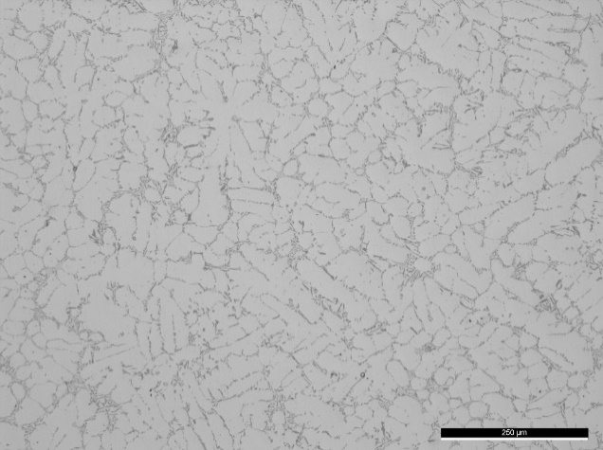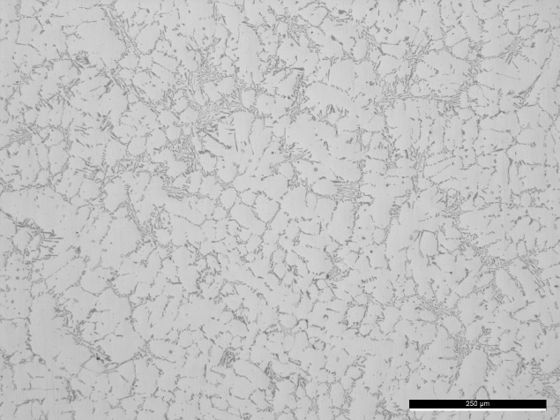

In any close to ideal liquid, viscosity and thermal conductivity are the two main factors responsible for acoustic attenuation. However, in molten melt obtained from commercial alloys, the effect of impurities is equally important. In fact, the contact between the front of acoustic wave propagation and the particles suspended in the liquid medium, typically oxides and non-metallic inclusions, promotes a decrease in the value of the acoustic intensity due to its partition into reflected and transmitted waves with arbitrary orientations. Cumulatively, the presence of particles in large density and cavitated bubbles in the vicinity of the acoustic radiator can contribute to acoustic attenuation losses due to the scattering effect. Because of acoustic attenuation, the cavitation decreases with increasing distance from the acoustic radiator, determining a threshold volume when this phenomenon occurs. To overcome such challenges, two concurrent systems can be implemented: (i) application of ultrasonic MMM Concept through the variations of the parameters realized by the dedicated software (frequency sweeping, amplitude modulation …); (ii) implementing a hybrid ultrasonic degassing system combined with a Dynamic Stirring rotation, able to cover the entire metal volume.

- MMM concept – dedicated Software (an advantage compared to the competition, here we have full control of the degassing process).

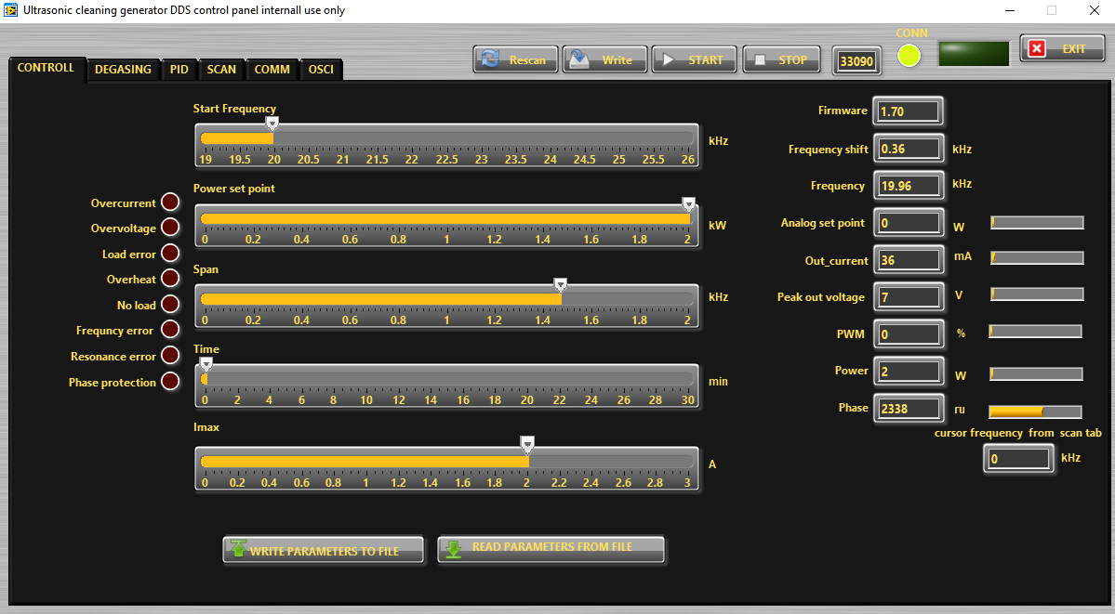

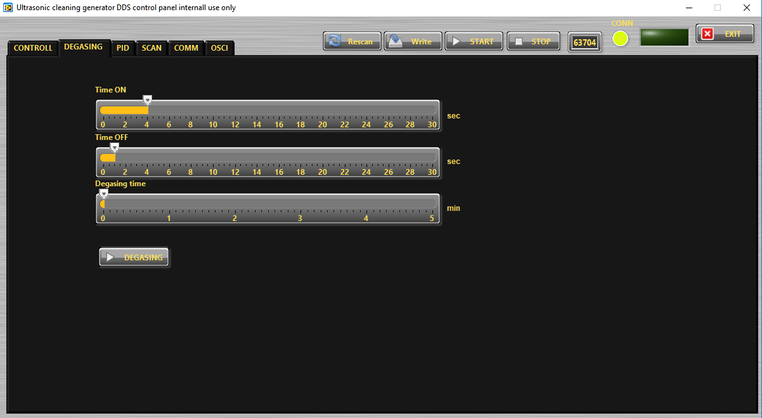
(ii) Dynamic Stirring rotation
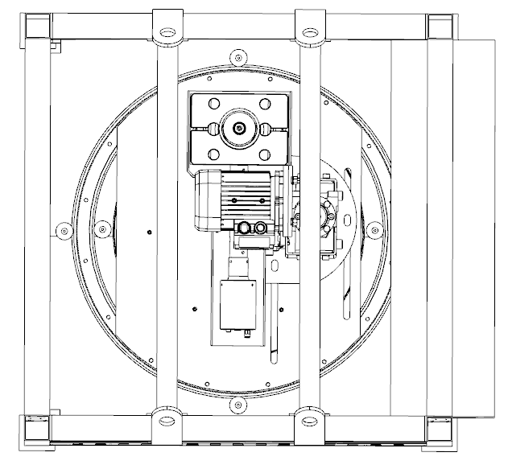
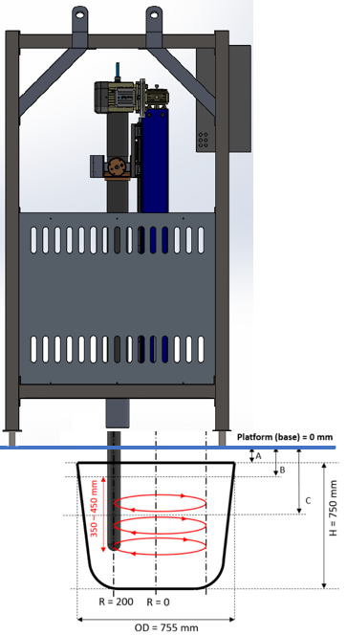

In ultrasonic degassing, the cavitated bubbles in the vicinity of the ultrasound radiator, due to an acoustic attenuation phenomenon already mentioned, are transported to the surface of the molten melt by the density difference and/or by acoustic liquid flows developed at the moment of their collapse, removing dissolved gases (mainly hydrogen) and suspended inclusions. However, not all cavitation bubbles reach the surface, since part of them are transported to volume areas with insufficient acoustic intensity, eventually dissolving in the liquid. This mechanism slows down the ultrasonic degassing process, limiting the maximum density obtained, i.e., the degassing efficiency.

Using the hybrid or combined ultrasonic and traditional degassing system, we can overcome the limitations of application of ultrasound, since a much larger amount of liquid metal is forced to pass close to the acoustic radiator, entering the well-developed cavitation regime. The advantage of ultrasonic degassing (without Dynamic Stirring with rotation) becomes more evident when processing time increases, and the dissolved hydrogen content decreases. At the beginning of degassing, this effect is not so noticeable because the dissolved H atoms amount is high, and the distances between them and cavitated bubbles is small, making the diffusion process easier. In applications of fixed frequency ultrasonic processing (as known in all ultrasonic systems from competitors), formation of H2 molecules, or diffusion of H atoms into cavitating bubbles, is difficult due to a small number of remaining H atoms, and large distances between them. However, the specific flow profile of the motion induced into a liquid metal by the Dynamic Stirring rotation produces that H atoms will approach the surface of the acoustic radiator (SialON sonotrode), facilitating their diffusion into cavitated bubbles, followed by their expulsion to the surface of the molten melt. Furthermore, the increase of degassing efficiency by combining the ultrasonic MMM Concept and dynamic stirring (compared with fixed frequency ultrasonic systems from competitors) is more evident for lower degassing processing temperatures, and lower levels of H dissolved in the medium. When we have a bath with a high level of dissolved hydrogen it is easy to make degassing, but when the remaining dissolved hydrogen present inside of the bath is in small amount, it is necessary to apply an additional effort to clean it (what is a Dynamic Stirring with rotation).

Alloy A380 (AlSi9Cu3)
Temperature of degassing 700 ºC

For low temperatures, three factors contribute to decreasing the ultrasonic efficiency degassing: (i) decreasing temperature promotes an acoustic waves attenuation; (ii) the mobility of H atoms in the liquid decreases, thus decreasing the diffusion of hydrogen from the liquid into cavitating bubbles; (iii) an increase in the viscosity of the liquid makes the development of cavitation difficult.

These drawbacks are overcome by the combination of the effects, where the molten metal volume subject to the development of cavitation development is larger (Dynamic Stirring by rotation), and the low mobility of the H atoms is compensated by the movement of the liquid helped by application of MMM Concept through the variations of relevant parameters. However, the equilibrium plateau of density in molten metal degassed at low temperatures is lower than for higher degassing temperatures, and the movement of the liquid does not fully compensate for the difficulty in developing cavitation. Therefore, even using the combination of agitation by ultrasonic effects and by Dynamic Stirring rotation, the best degassing results do not correspond to those obtained for higher processing temperatures in terms of an absolute efficiency.

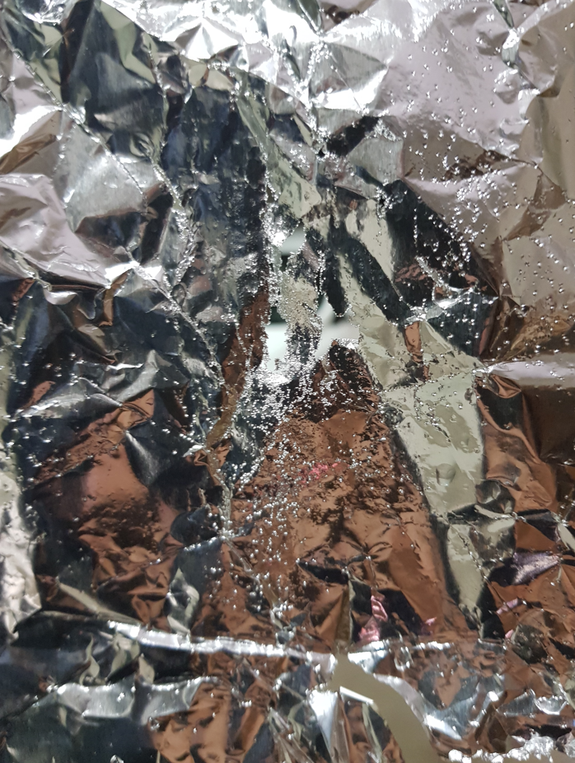
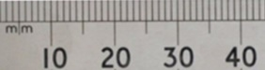

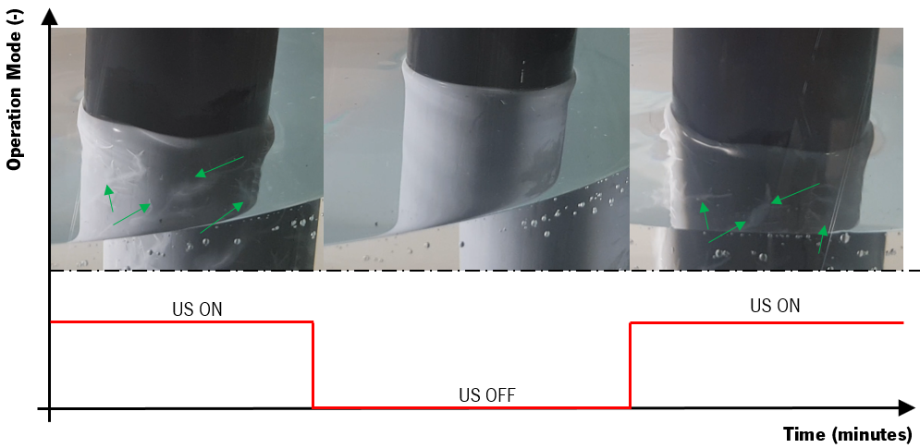
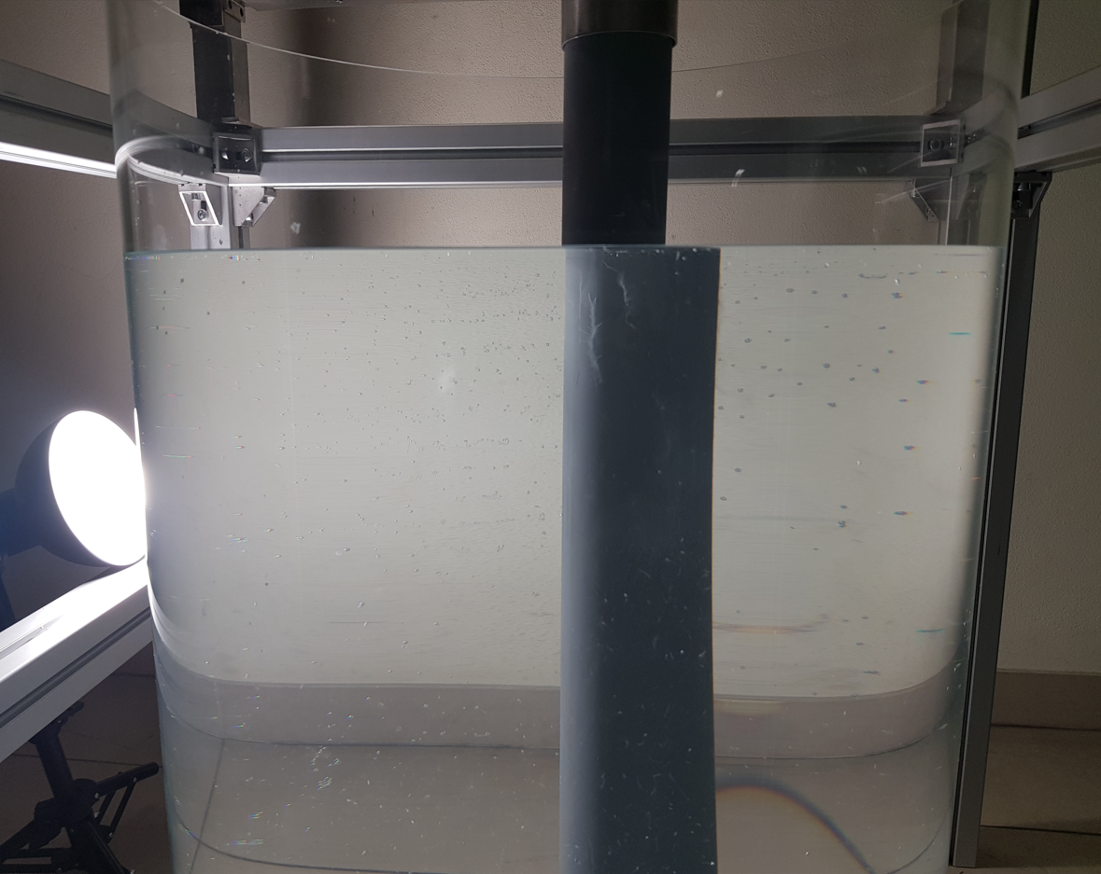

Refinement/Modification:

The grain size stands an inverse relationship to the number of solidification nuclei present in the liquid alloy that will act during solidification. If each grain forms from one single particle or nucleus (heterogeneous nucleation), it is easily understood that as more nuclei are germinated, more grains will form. Thus, if the number of nuclei is sufficiently high and well-distributed surrounding the molten melt, dendritic structures can be avoided, and globular grains of primary aluminum will preferentially form.

Besides the chemical technique, microstructure refinement can also be achieved by physical means. During the last years, an effort has been made to develop reliable ultrasonic techniques to control the microstructure of several engineering alloys, with particular emphasis to Al and Mg alloy ones, to overtake the problems associated to traditional refinement techniques. Indeed, the alternating pressure achieved by the application of MMM technology above the cavitation threshold is promoting numerous of low pressure (almost vacuum) bubbles in a liquid metal, which starts growing, pulsing with a continuous expansion, bubbles absorb energy in the melt, undercooling the liquid at the bubble-liquid interface, resulting in nucleation on the bubble surface. When bubbles collapse, acoustic streaming develops in the molten melt, distributing the nuclei into the surrounding liquid producing a significant number of nuclei in the molten alloy, thus promoting heterogeneous nucleation.

Several models and mechanisms explaining the effect of ultrasonic vibrations on grain refinement have been proposed, namely dendrite fragmentation and cavitation-enhanced heterogeneous nucleation. However, cavitation-enhanced heterogeneous nucleation mechanism seems to be considered the most valid hypothesis, as claimed by several authors during last years.

An important consideration that can be taken from years of experimentation is:
How to apply ultrasonic vibrations to promote grain refinement?

Here we can answer in two different ways: (i) isothermal way; (ii) continuous way. Both have positive and negative aspects. Also, it will be dependent on the cast house process where we need to apply ultrasonic processing.

In an isothermal way, we need to submerge an ultrasonic tool (sonotrode/radiator/emitter) into the molten melt at a specific temperature and vibrate the liquid isothermally for a certain period after which the ultrasonic tool is removed, and the molten alloy poured in a steel die pre-heated. In the continuous approach, we need to submerge ultrasonic tool (sonotrode/radiator/emitter) into a molten melt at a specific temperature and vibrate the liquid continuously. The latter is more realistic and applicable in the gravity die casting process. The less favorable point is that the processing temperature cannot be too low due to the inherent casting process.

The following figure represents the as-cast microstructure of the AlSi7Mg0.6 alloy isothermally submitted to acoustic energy at 690 ºC, at 600 W ultrasonic power and 19.8 kHz frequency.

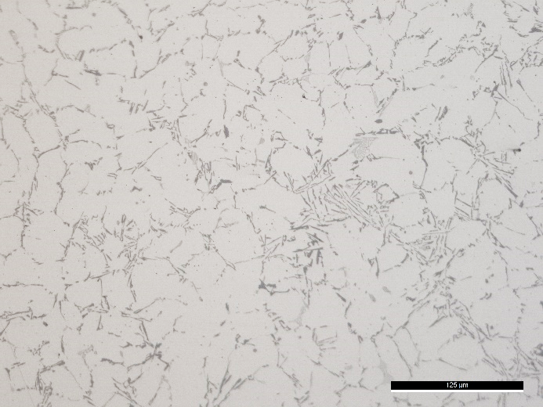
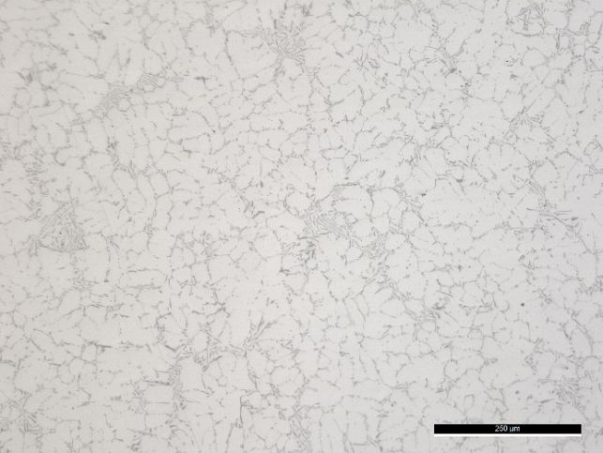

Another approach is to indirectly apply the ultrasonic tool (sonotrode/radiator/emitter) to the molten melt. It means, by coupling the acoustic tool to a mold, and supplying vibrations during solidification. This approach brings advantages such as better grain refinement, intermetallic refinement, eutectic silicon; however, on the other hand, it is more difficult to apply and control it in other industrial practices.

Some examples of microstructure obtained in the laboratory using the indirect approach can be seen below.

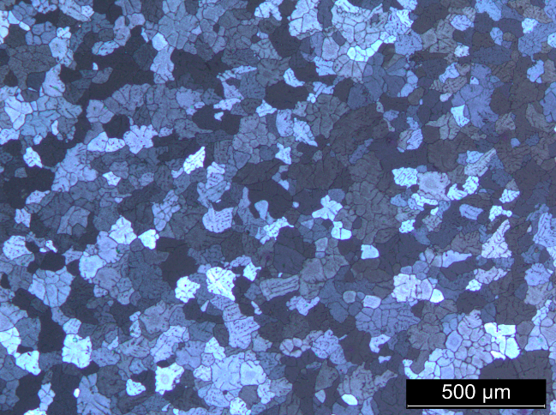
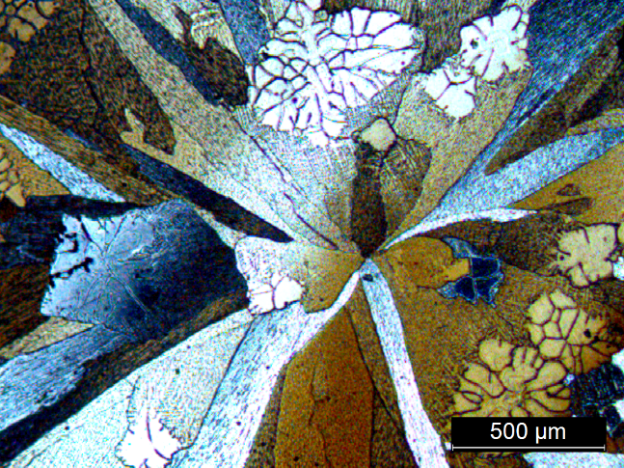

This approach is very interesting for the refinement of secondary phases and modification of eutectic silicon. The application of ultrasonic vibrations to the melt during cooling proved to be very effective in converting the intermetallics with Chinese script morphology to polyhedral crystals (e.g., in A380 alloy), at the same time suppressing the formation of the β-phase. Moreover, the application of this treatment only changes the morphology of α-intermetallics since its stoichiometry remains the same (α-Al17(Fe3.2,Mn0.8)Si2). It was also verified that the application of acoustic energy to the melt also changes the grain growth direction of the matrix, since in this case the α-Al grains don’t grow in a preferential plane, showing a globular shape.
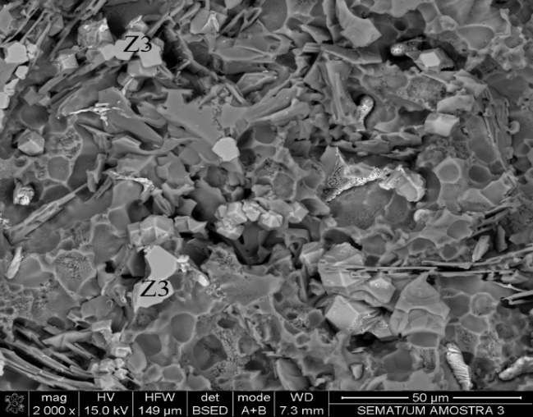
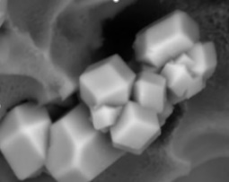
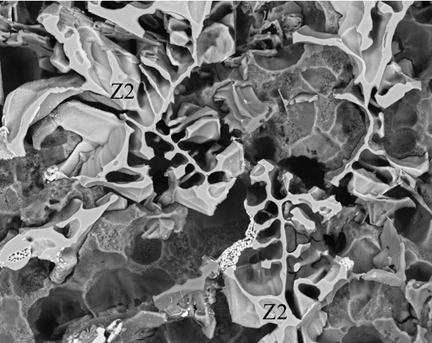

(3) Basic equipment set up in foundry environment

Besides our main advantage of MMM technology regarding competition, we are using the most advanced techniques and multidisciplinary knowledge to develop basic equipment able to be adapted to the foundry environment without a significant investment. All materials, concepts, and approaches are specifically designed, assembled, and tested in the laboratory, and then applied in the industrial environment.

At the very initial steps, and according to the cast house's conditions, a virtual software prototype is created, being numerically validated, and manufactured.

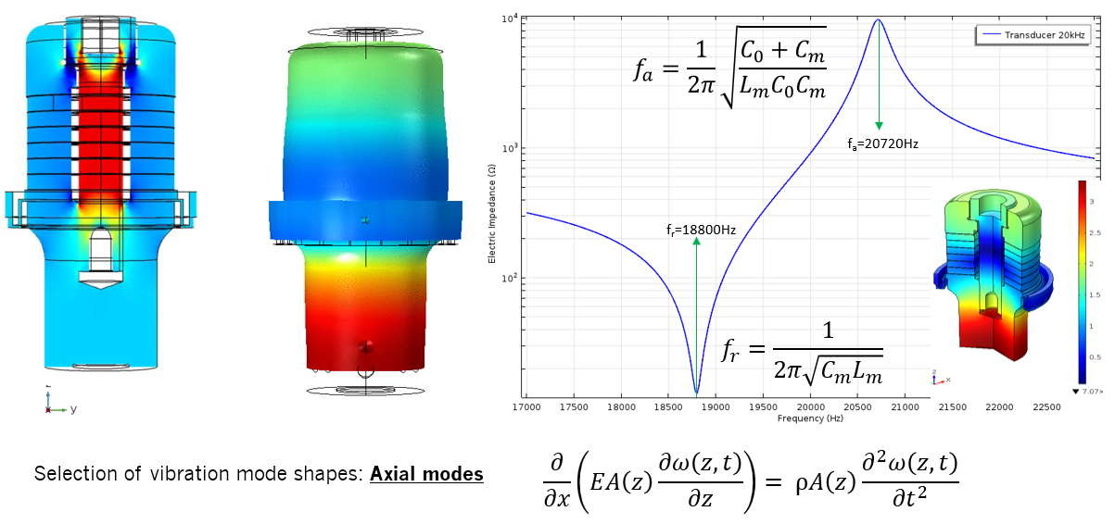

A specific and well-developed software (see figure) integrating the ultrasonic generator allows a correct adjustments/optimization with the best operating parameters of ultrasonic transducer and generator.
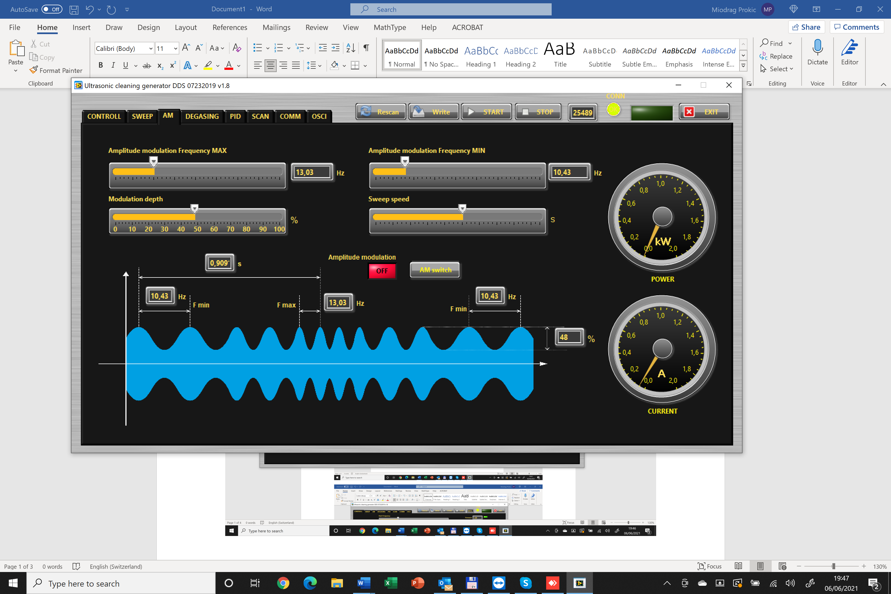
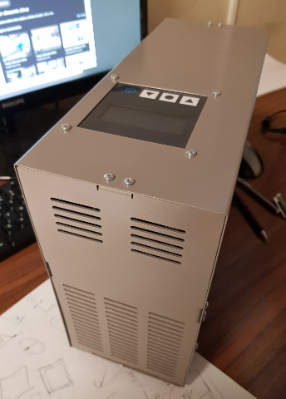

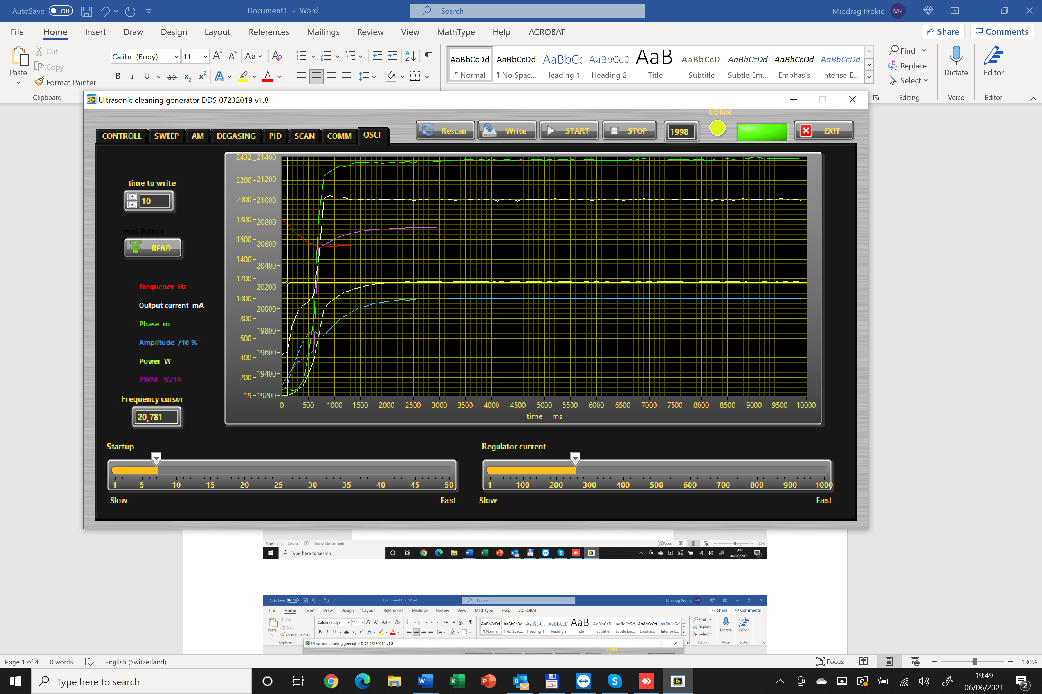
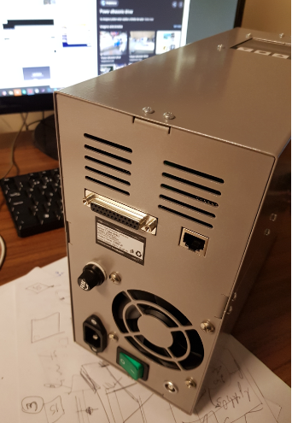

(4) How is MMM different than Southwire's offering

Southwire is offering fixed ultrasonic frequency liquid metal agitation using high intensity probe sonication. That means, producing spatially not uniform “ultrasonic-jet or ultrasonic-torch” agitation. In the same time Southwire patented design is convenient for injecting argon or nitrogen for stimulating degassing (in parallel with ultrasonic activity). Anyway, high intensity “ultrasonic-jet or ultrasonic-torch”, and presence of injected gas in front of ultrasonic probe are mutually contra-productive and could reduce expected effects. Every fixed frequency ultrasonic probe sonication can also inject big quantity of gasses in liquids if not properly applied (that means, degassing with probe-sonication is not reliable).

(5) Conclusion:
Statement about 5th generation MMM technology and its readiness for industrial application in foundries.

MMM technology is becoming the symbol for Macro Ultrasonic Engineering, meaning that arbitrary-shaped, small, and big objects or masses can be ultrasonically and uniformly agitated with high power. MMM technology is much different when compared to very high frequency and very low power NDT (Non-Destructive Testing).

