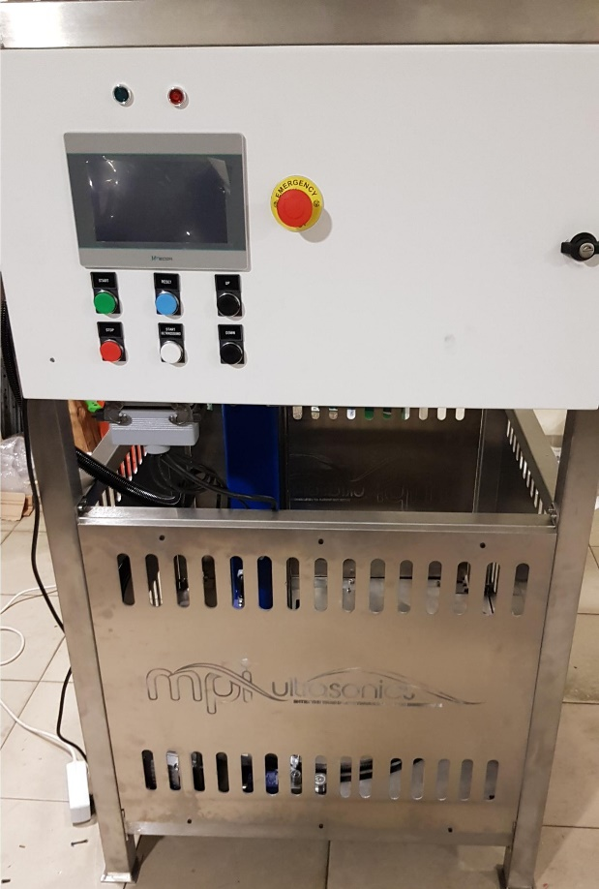
MPInterconsulting
Le Locle - Switzerland
http://www.ultrasonicmetallurgy.com
November 2021
Operation Manual for Ultrasound Aluminium Melt Treatment Equipment

CONTENTS

INTRODUCTION
SAFETY INSTRUCTIONS
INSTALLATION & ENVIRONMENT
POWER SUPPLY
SETTING THE MELT TREATMENT CYCLE PROPERTIES
MAINTENANCE
ELECTRICAL SCHEMATICS

INTRODUCTION

Dear Customer,
Thank you for your purchase of the product.
This ultrasonic aluminium alloy melt treatment device has been developed using the latest technologies to allow for greater overall performance and stability.

Please read and follow these operating instructions carefully before installing or commissioning your product. As with any electrically powered device, failure to observe these instructions can present a risk to life.

The device may only be operated and maintained by personnel who have read and understood
this operating manual and are familiar with the applicable legal regulations for accident prevention and workplace safety. Failure to comply with this will result in a loss of warranty rights.

SAFETY INSTRUCTIONS

Before starting up your device, please read through the following instructions carefully, both for your own safety and for the safety of the device. The equipment has been designed and engineered to provide a simple, safe, efficient and convenient operation. Operating it requires very little training or skill and a minimum of physical effort. You will need to read the operating manual for the temperature controllers so you may set and operate them correctly.

Keep this manual where it can be readily accessed by all systems users.

Installation is to be carried out by qualified technical personnel only!

This device is to be operated by properly trained personnel only!

All necessary settings were either made in the factory or are described in this manual.

Inspection or diagnostic work inside the device may only be carried out to the extent described and, as with the electrical connection should only be performed by skilled personnel. When performing such work, the control device must be completely disconnected from the main power source.

The device must always be disconnected from the mains before cleaning or when installing/uninstalling an option. Do not use liquid cleaners or sprays. Only use pressur air.

The handling and platform for the device must be sufficiently stable, as the device being jolted or falling could cause severe damage.

Ensure that the power supply specifications given on the device are met.

ATTENTION: Repairs and modifications may only be carried out by competent, skilled personnel.

INSTALLATION & ENVIRONMENT
Dimensions:
H = 1600 mm; L= 1050 mm; W = 900 mm
Weight:
230 kg
Handling:
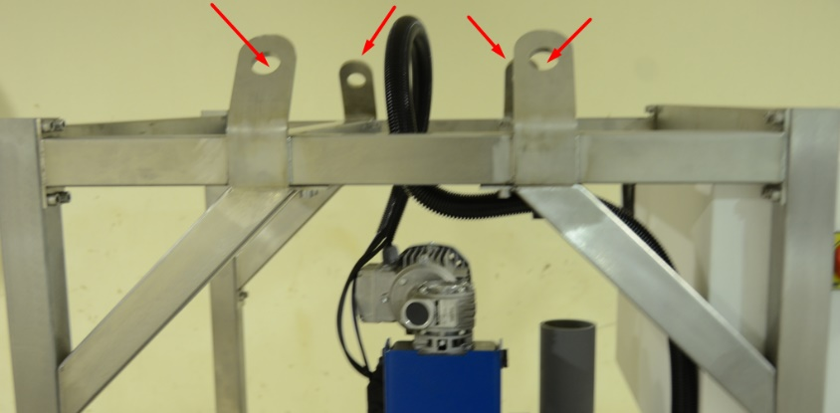

POWER SUPPLY
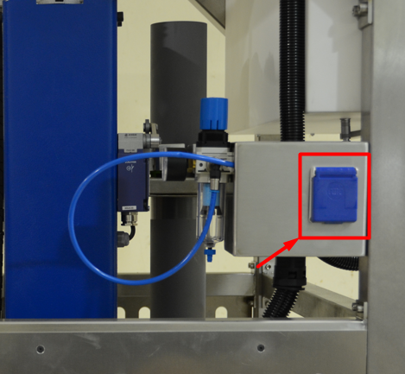
210-250VAC/50-80Hz

Connect the furnace to the exact electrical voltage described before. A copy of electrical connections is also in the preceding pages. Be sure that you’re wiring and fusing to the equipment is sufficiently over-sided consistent with local building codes.
SETTING THE MELT TREATMENT CYCLE PROPERTIES
1. Switch On the lateral button:
2. Login Password manager: 1000 (after you can change as you like).
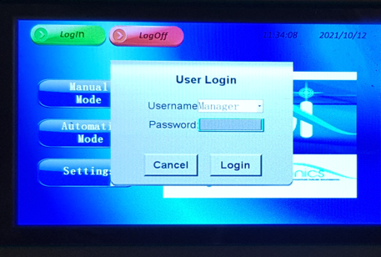
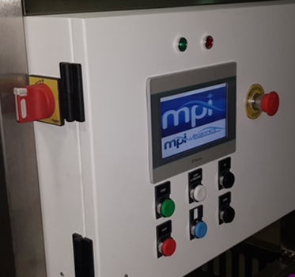
3. Description of Buttons Instaled in Controller Painel:
1
2
7
5
6
4
8
3

1 | Emergency BUTTON
2 | ON/OFF BUTTON
3 | Up Sialon Tube
4 | Down Sialon Tube
5 | Start Cycle
6 | Stop/Resent Cycle
7 | Start Ultrasound
8 | Stop Ultrasound

4. Select Cycle Mode: Manual or Automatic

4.1 In the MANUAL Mode, the device executes all Melt Treatment setting adjusted manually by the operator.
In the MANUAL Mode, the Up/Down and Start/Stop Ultrasound adjustments can be made either in Touch Screen or the Buttons on the Front Panel. The CCW/CW Direction Adjustment just can be made on Touch Screen.
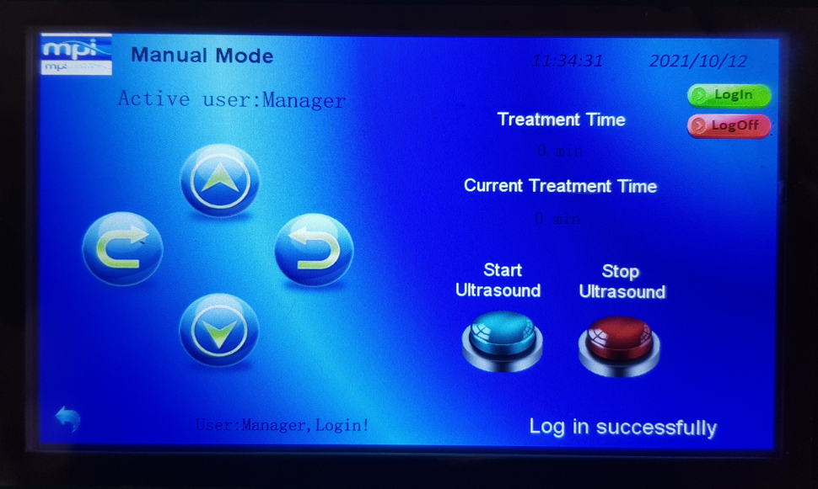
Up – Movement of Sialon Tube in ascendant direction
Down – Movement of Sialon Tube in descendent direction
CCW – Movement of Sialon Tube in CCW direction
CW – Movement of Sialon Tube in CW direction
CCW – Movement of Sialon Tube in CCW direction
Treatment Time – Total Time of Melt Treatment by Sialon Tube
Current Treatment Time – Remaining Time of Melt Treatment by Sialon Tube
Start Ultrasound – Start of the ultrasonic treatment cycle
Stop Ultrasound – Stop the ultrasonic treatment cycle
ATTENTION:
Only when Sialon Tube is in the position of treatment, the Start Ultrasound should be PRESS.
Do not PRESS Start Ultrasound with Sialon Tube outside of melt.
5. In the AUTOMATIC Mode, the operator can use one of the three different modes
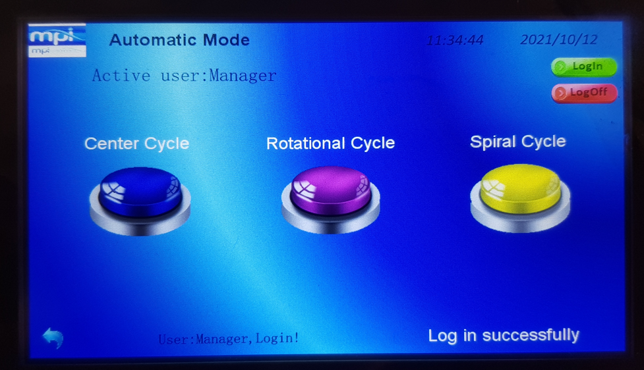
5.1 AUTOMATIC Mode – Center Cycle
In this mode, the equipment execute melt Treatment without rotation of Sialon Tube
5.2 AUTOMATIC Mode – Rotational Cycle
In this mode, the equipment execute melt Treatment with rotation of Sialon Tube
5.3 AUTOMATIC Mode – Spiral Cycle
In this mode, the equipment execute melt Treatment with rotation and Up/Down of Sialon Tube
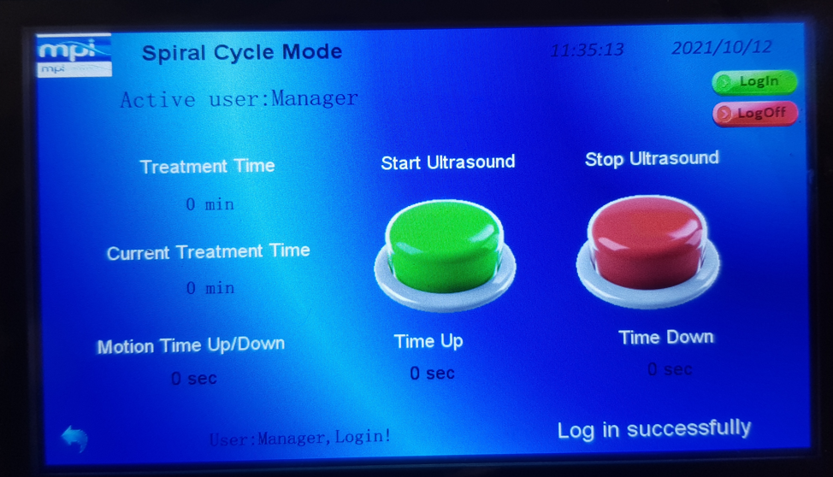
6. The manager can change the settings:
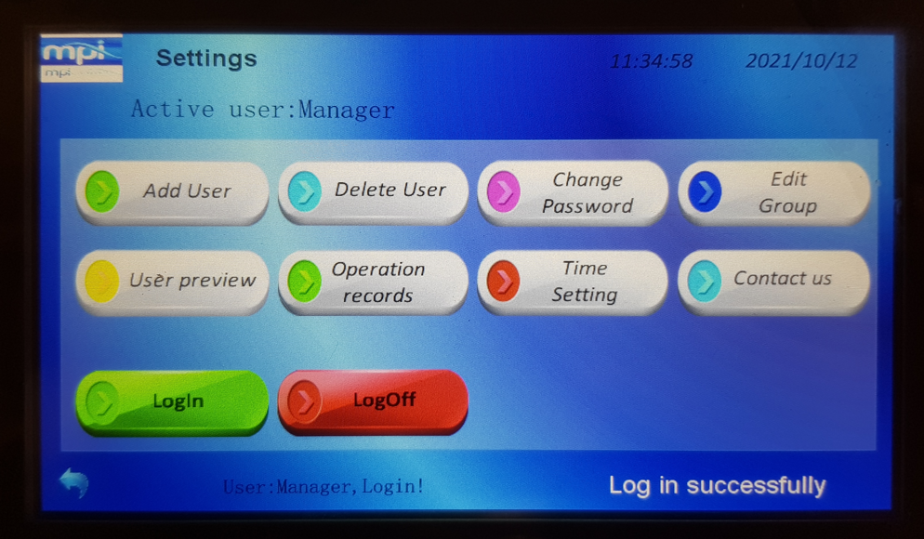
7. WORKING WITH SIALON TUBE - Considerations
7.1 SEQUENCE OF WORK with Sialon Tube in Crucible
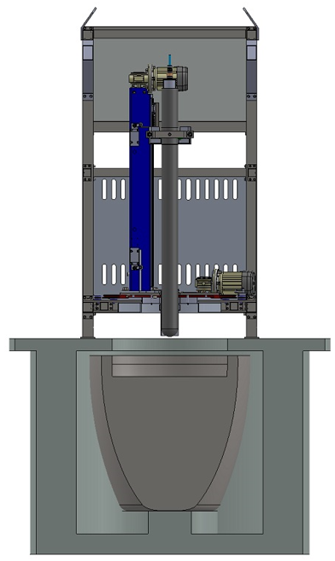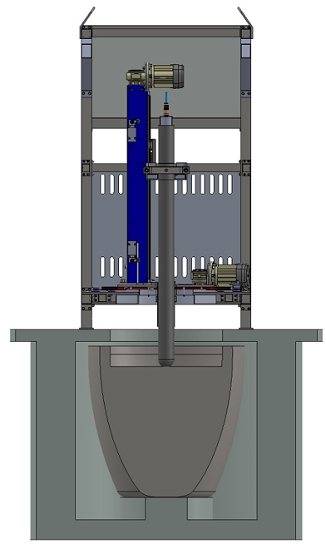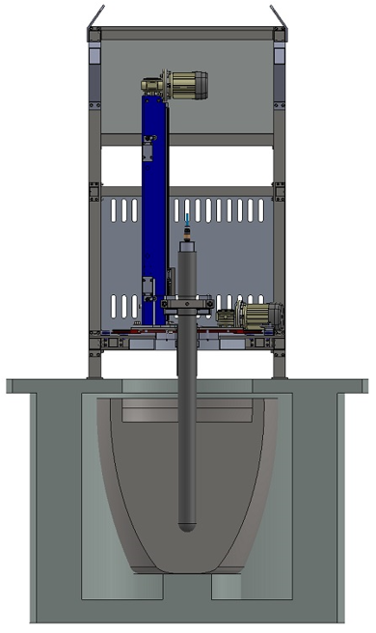
Top Position
Position for Heating of Sialon Tube
Lower Position

7.2 DIMENSIONS OF WORK – Minimum and Maximum Sialon Tube Positions
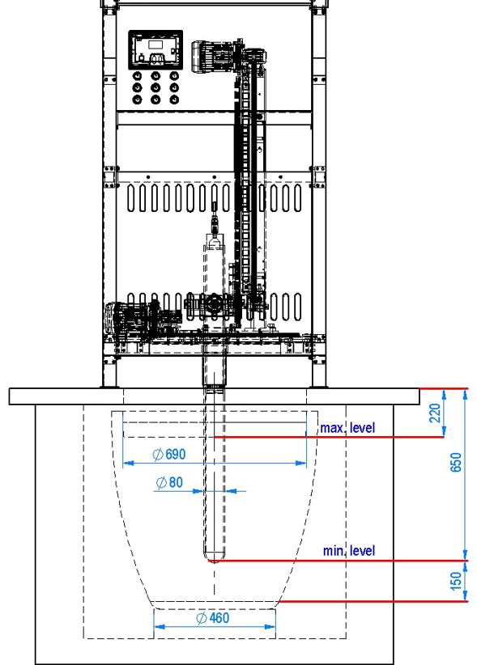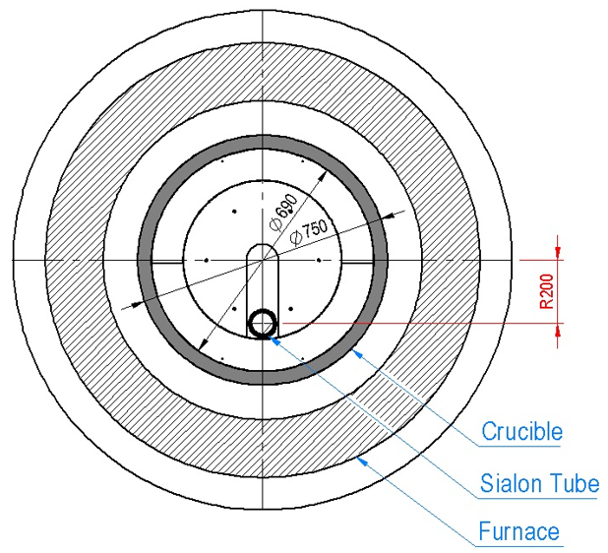
NOTE: The Distance from center of Sialon Tube to center of the crucible can range from R = 0 mm to R = 220 mm (R = 0 mm must be used with AUTOMATIC Mode – Center Cycle).
WARMING: For make melt treatment, the Sialon tube must be deeped at least 350 mm in the liquid.
6.3 ELEMENTS OF EQUIPMENT

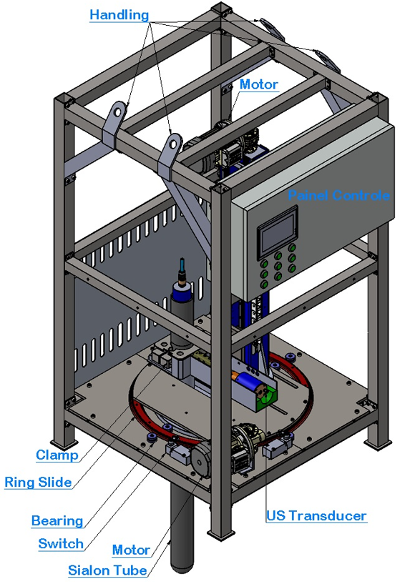
MAINTENANCE
Qualified technicians must maintain this equipment. Before beginning any work on the system, the person shall ensure that all security precautions have been taken. Personnel working on the electrical or heated components must be authorized, trained and fully qualified.
CAUTION!
Combustible materials must not be placed in, on or near the furnace.
Do not set or place any materials, tools or liquids on top of the furnace.
All controls, switches and pyrometers are subject to failure. You should check the furnace periodically to be sure it is heating properly.

GENERAL PREVENTATIVE MAINTENANCE:
1. Turn power switch “OFF.”
2. Clean rear ventilation port and louvers.
3. Clean interior of control panel if dirty.
4. Use hands that are free of dirt, oil, chemicals, etc., while setting the controller parameters.
5. Use care not to damage the Sialon Tube while loading or unloading.
6. Re-grease double edge ring slides and shaft bearings (located in the equipment base) with high temperature grease every week.
8. Inspect the condition of all motion components and re-grease them if necessary.
9. Supply enough air cooling to the transducer and clamp-on (5 - 6 bar).
10. The base of equipment was filled with four levels of UNIFRAX (ceramic layer ). Make periodic inspections to avoid heating components inside the box (motor, switches, ring slides, and bearings).
11. Before emerging Sialon Tube inside the metal, please slowly heat (attention to thermal shock). Use the hand control to lower the Sialon Tube to the liquid metal surface. Leave it in that position for 5 to 10 minutes to warm up. After that, lower at least 350 – 400 mm inside of liquid to start the melt treatment. Use the desired operation cycle.
12. After finish the melt treatment, the Sialon Tube will come to the initial position (rear position). The equipment is prepared to clean the material stuck to the tube automatically. However, with help a dry cloth, wipe the surface of the Sialon Tube with a clean and dry cloth.

TROUBLESHOOTING
Symptom | Case | Solution
Transducer heated | Fail air supplying; air pressure insufficient | Increase the air pressure; replace the cooling pipe if necessary.
Motors heating | Engine power; dirty environment; Lack of lubrication of the rails | Clean the engine fan; make cleaning daily the engine enclosure; Re-grease the rails
Clamp heating | Fail air supplying; air pressure insufficient | Increase the air pressure; replace the cooling pipe if necessary; adjust the ultrasonic parameters
The Sialon Tube doesn't work | No power to the generator; parameters wrongs; Sialon Tube broke; Clamp broken | Make a new scan of the ultrasonic system; adjust the frequency; check the integrity of Sialon Tube; check the integrity of clamp.

WARNING: Always disconnect power before servicing electrical parts.

MMM Generator
1. COMM Tab
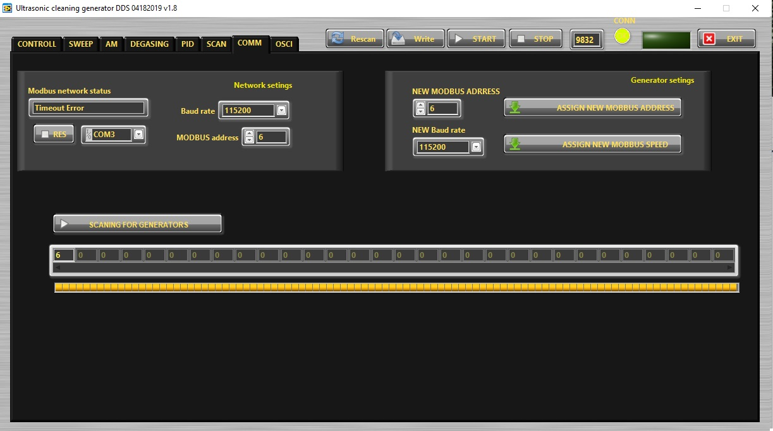
COMM (1) Choose correct COM (2) Red light will change for green (3)

2. CONTROL Tab
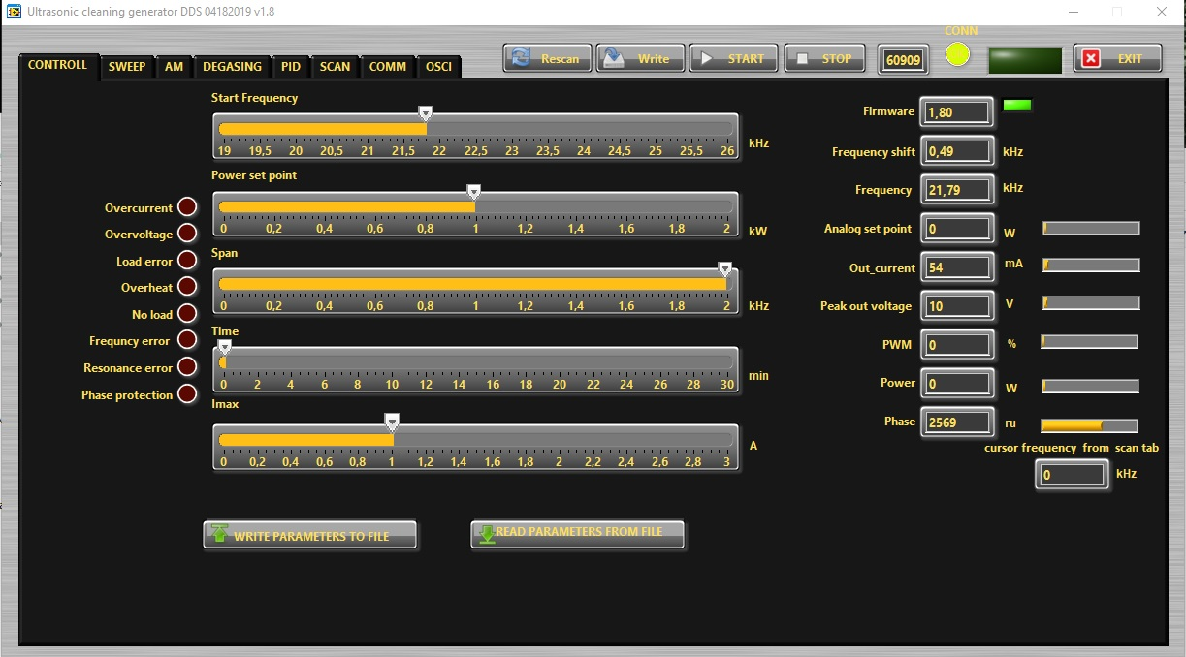
Tab Controll (1)

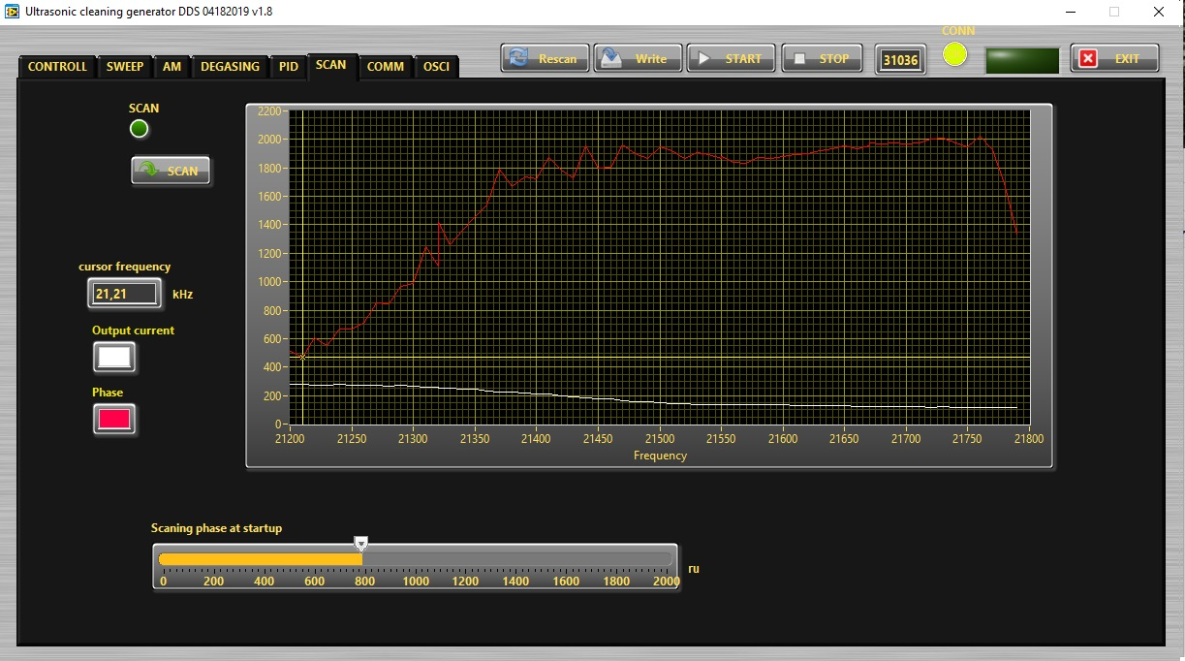
3. SCAN Tab

4. DEGASING Tab
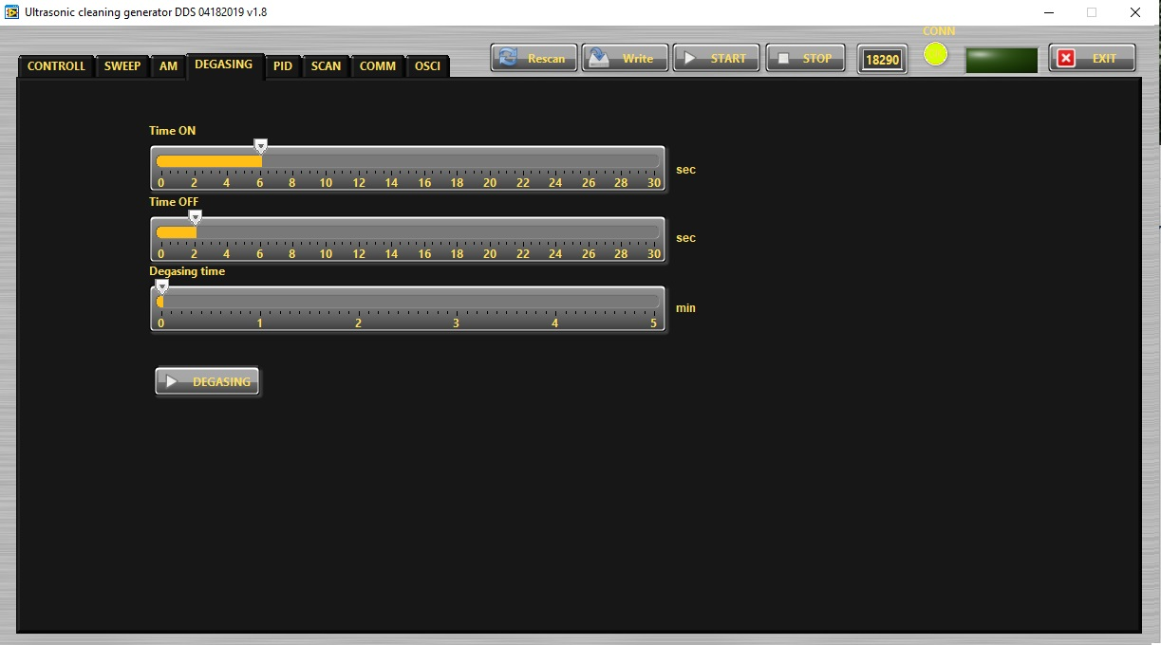
Find and activate the optimal Degasing regime, when a cleaning liquid has lot of dissolved gas .
Time ON – Set the operation time of the generator in degasin regime.
Time OFF – Set the non-operation time of the generator in degasin regime.
Degasing time – This the total time the generator was switched ON in degassing mode.

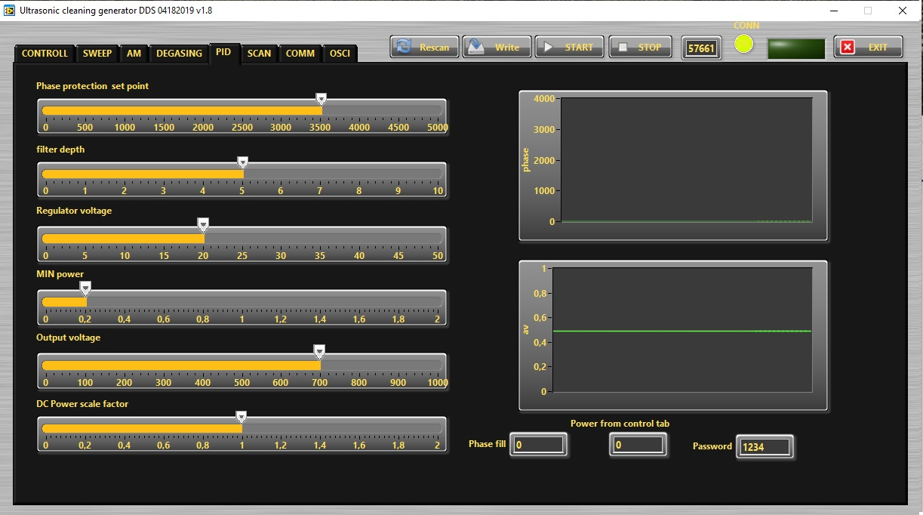
5. PID Tab

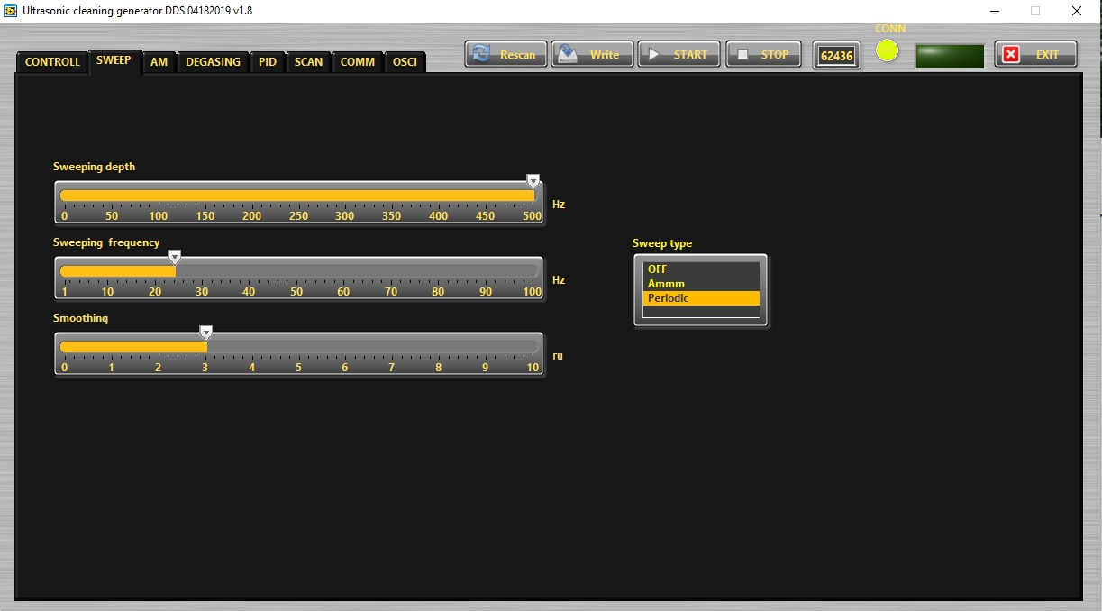
6. SWEEP Tab (Carrier frequency sweeping)

Sweeping depth– This is the deviation of the sweeping frequency around the central operation frequency in Hz.
Sweeping frequency – Here you can set the desired sweeping frequency in Hz.
Smoothing – This changes the shape of the sweeping frequency from rectangular to similar to sinusoidal.
Sweeping Type – in three possible modes: OFF – no sweeping; AMMM – semi-random sweeping; Periodic – periodic sweeping.
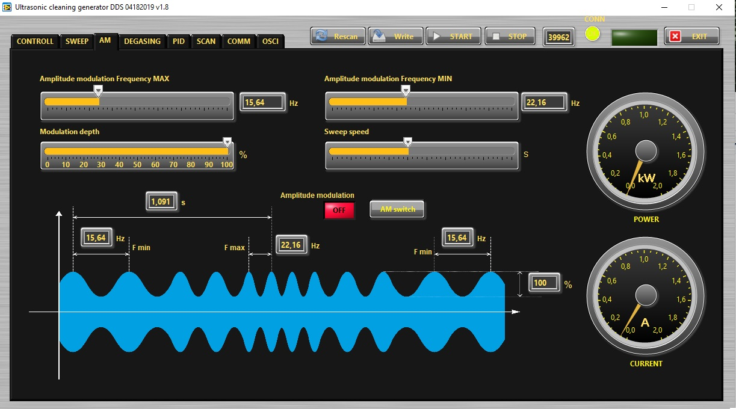
7. AM Tab (Amplitude Modulation Tab)
Amplitude modulation frequency MAX – This the maximum value of the frequency of the amplitude modulation.
Modulation Depth – This the the depth of the amplitude modulation.
Amplitude modulation frequency MIN – This the maximum value of the frequency of the amplitude modulation.
Sweep speed – This the speed of changing from Amplitude modulation frequency MIN to Amplitude modulation frequency MAX.

Find and activate the optimal AM regime, when you need it.

ELECTRICAL SCHEMATICS

