Simplified Arithmetic Hilbert Transform
based Wide-Band Real-Time
Digital Frequency Estimator

Jean-Paul Sandoz

Professor of Electronics and Signal Processing

Part 1 Introduction

Part 2 Basic Theoretical Analysis

Part 3 Implementation

Part 4 Simulation Results

Part 5 Conclusions

Part 1 - Introduction

Objectives of this work

- To develop a practical solution to FPGA/CPLD implementation of a Hilbert Transform (HT) based Instantaneous Frequency Estimator.

- Multiplication-free structure

Most significant Innovations

- Substitution of the Arctan function by the ″One-Bit″ based balanced Quadri-Correlator.

- Up Frequency Conversion and Single-Side Band generation at IF to achieve a wide Frequency Range of operation.

Key Advantages

- Maintain good performances in Impulsive Noise environment and/or Variable SNR

- Low Power consumption designs or High Frequency applications.

Important characteristics

- Frequency range of operation: 200 Hz → 4 kHz

- Low system clock frequency: 80 kHz

- Tracking error standard deviation of slow varying frequency: 3 Hz

- Group delay: 3 ms

- 200 Hz to 4 kHz transient time (10% → 90%): 2.5 ms

- Maximum to minimum frequencies of operation ratio: 20

- Resistant to wide-band additive background noise

- Very robust to impulsive noise

- Fully controllable frequency estimation accuracy and response time

Principal blocs constituting this design

- Multiplication-free all-pass digital filter Hilbert Transformer

- Multiplication-free up-frequency converter

- Single–side band generation at intermediate frequency
(IF = 6 → 9.8 kHz)

- “One-Bit” based balanced Quadri-Correlator” operating at IF

- Running Averagers controlling the frequency estimator
dynamic performances

Part 2 - Basic Theoretical Analysis

Bloc diagram of the complete structure

- x_{in}(t) = A(t) ⋅ sin[2π freq_{xin}(t) ⋅t] : Input signal

freq_{xin}(t) = Instantaneous frequency , 200 Hz ≤ freq_{xin} ≤ 4000 Hz

- The Hilbert Transformer output is an analytic signal x_{HT}(t) :
~
~
x_{HT}(t) = x_{in}(t) + j x_{in}(t) with x_{in}(t) = H [x_{in}(t)] = x_{in}(t)∗ (1 /π⋅t)

- The square-wave generator and the delay element produce a complex carrier with a fundamental frequency freq_{SQ} of 10 kHz

- The multiplier outputs are combined such that the lower side-band produced is an analytic signal :
LSB-In, LSB-Q

- The multiple harmonics generated by the square signal and present on this analytic signal are attenuated by low-pass filters.

Analytic signal instantaneous frequency : freq_{SQ} – freq_{xin}(t)

Hilbert Transform properties :

x(t) : Real function of time
•
~

•
~

~

f(t) = ω(t) / 2π : Instantaneous frequency

A(t) : Instantaneous envelope

Under certain conditions, ″One-Bit” balanced Quadri-Correlator determines the instantaneous frequency of its input signals !!

Duty cycle
proportional to
″In″ signal freq.
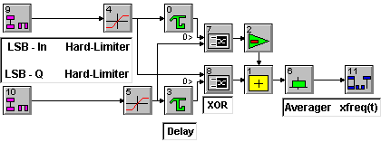

Bloc diagram of the ″ One-Bit” balanced Quadri-Correlator

Part 3 - Implementation

- Hilbert transformer

Three second-order all-pass filters and one unit delay element

.

Bloc diagram of the Hilbert Transformer
Where :

Numerical Optimization (i.e. coefficient round-off)

C_{k} = ± 2^{-m} ± 2^{-n}

( m ≤ 3 and n ≤ 4 , positive integers )

➔ Multiplication Free Implementation

Complex multiplier

- First inputs: Square-wave generator (i.e. +1 and –1) and its delayed version

- Second inputs: Hilbert transformer outputs.

➔ The implementation : two’s complement functions

Lower side-band selector

- Realized by ″Phasing Technique″ from complex multiplier outputs.
- Strongest unwanted frequencies : Attenuated by at least 10 dB

8 kHz 16 kHz 24 kHz 32 kHz 40 kHz
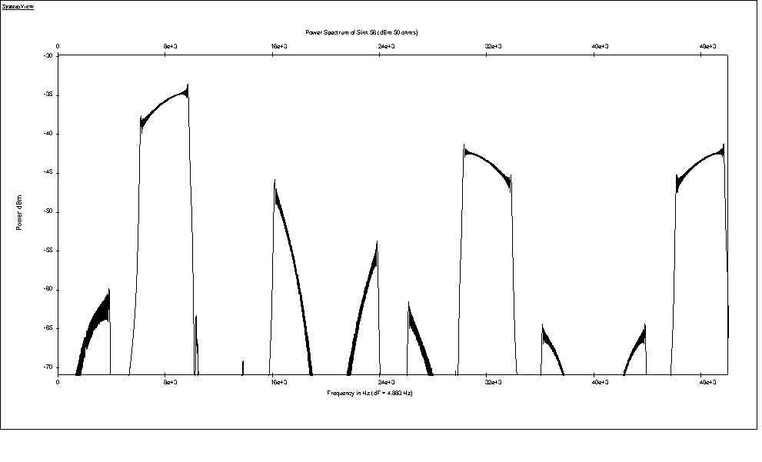
40 dB
From
Harm. 3
From
Harm. 5
Lower side-band output spectrum

Low-Pass Filter (realized with two identical averagers)

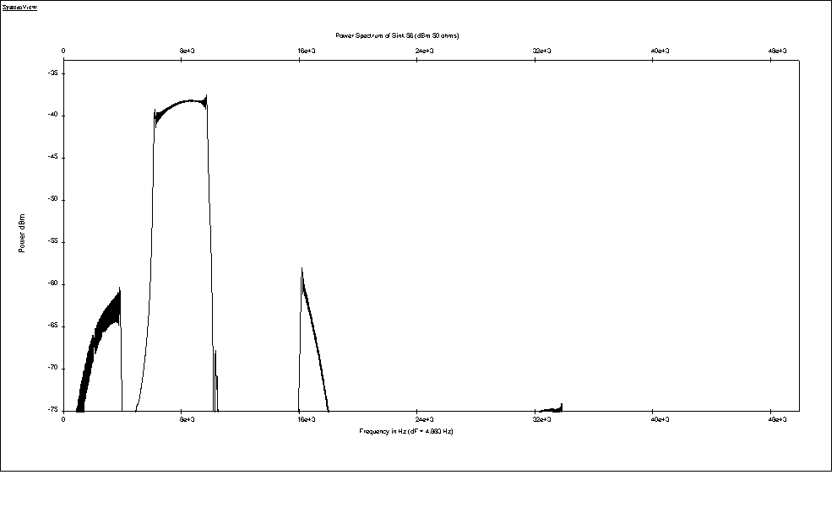
40 dB
Lower side-band + Low-pass filter output spectrum

Part 4 - Simulation Results

- Two Tones Test
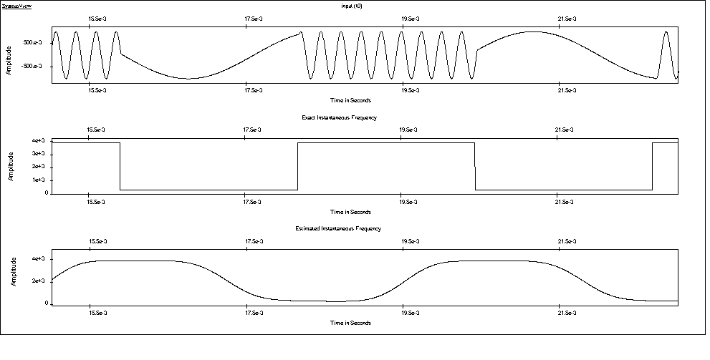

Top: xin(t) 300 Hz –3.9 kHz, Bottom: Instant. Freq. Estimation

- Fast varying Frequency

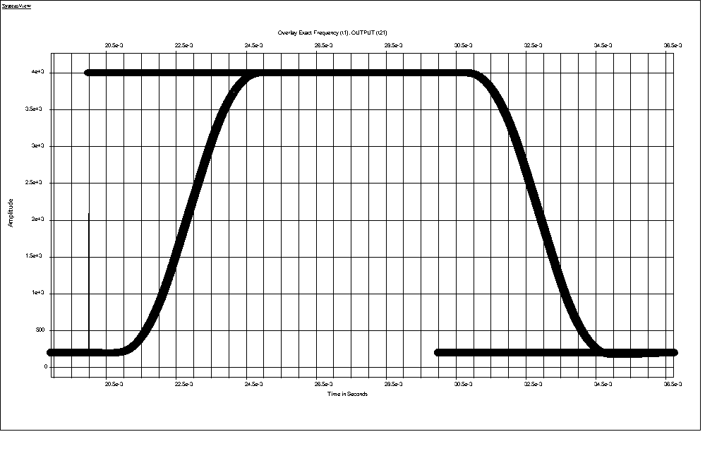

Input Signal Freq. (dotted) and Estimated Freq. (continuous)

τ_{g} (group delay) = 3 ms ; τ_{trans} (10% → 90%) = 2.5 ms

(Slow varying frequency tracking error: 3 Hz RMS)

- Sinusoidal Signal + Band-Limited Gaussian Noise

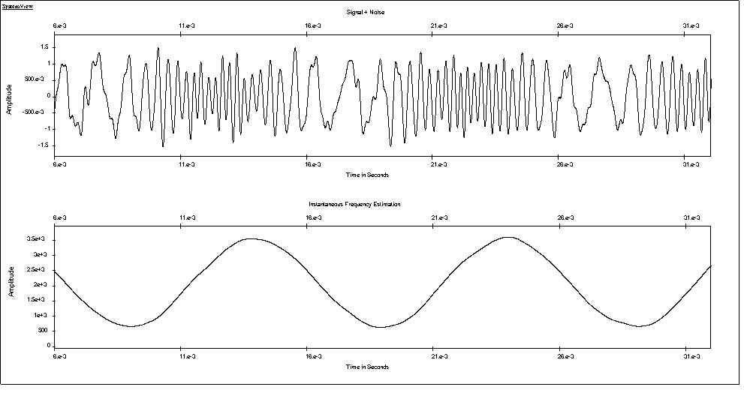
Top: Sinusoidal signal + Noise (SNR = 10 dB)
Bottom: Instantaneous Frequency Estimation

- Two Sinusoidal Signals with varying Frequencies

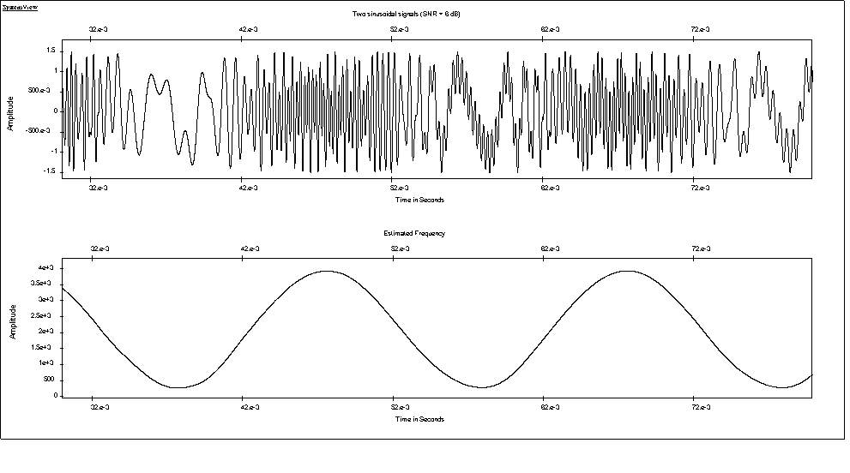
Top: Input signal (Signal₁ is 6dB stronger than Signal₂)
Bottom: Recovered Instantaneous Frequency of Signal₁

- Sinusoidal Signal and Impulsive Noise

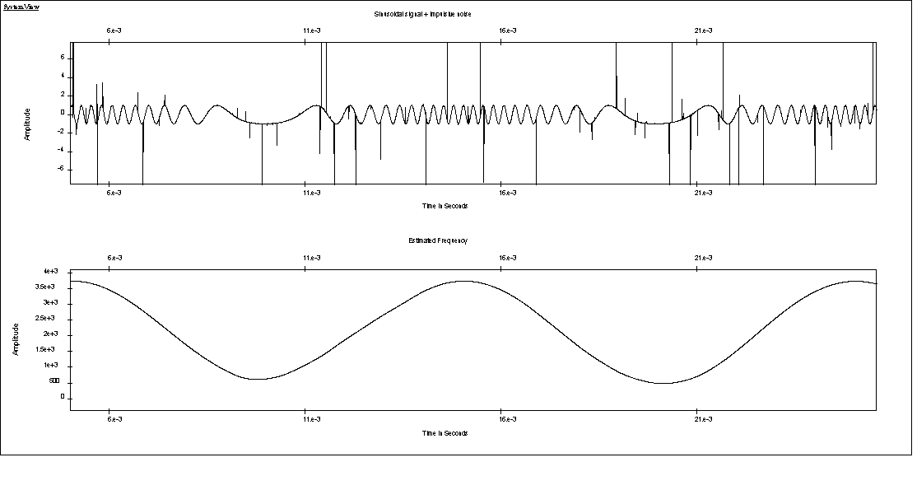
Top: Sine-wave + Impulsive noise; Bottom: Instant. Freq. Esti.

The original One-Bit″ signal processing technique implementation of the Balanced Quadri-Correlator provides a design that is inherently robust to impulsive noise and/or abrupt amplitude changes of the input signal !!

- Instantaneous Envelope and Frequency Estimation
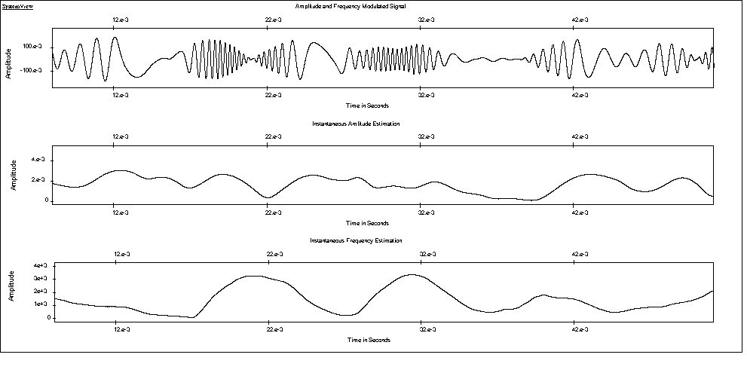
Instantaneous Envelope Estimation
Instantaneous Frequency Estimation
Top: Amplitude and Frequency modulated Signal
Center and Bottom: Instantaneous Ampl. and Freq. Estimation

Part 5 - Conclusions

The first series of computer simulations (SystemView) of the proposed new scheme have shown that:

- Its performances are very good in Non-Stationary Environment

- 100% multiplication-free

- Very good dynamic performances

- Overall performances match up the Arctan function solution

- Very robust against impulsive and/or burst type noise

- Instantaneous envelope estimation without complex computations

- Low power consumption designs or high speed applications

Current Fields of Investigation

- Dynamic speed measurement of very small electrical motors

- Instantaneous Frequency Estimation of Time-Decaying Processes

- Ultra-Sound based Instantaneous Velocity Measurement (Doppler)

Potential Applications

- Instant. Freq. Pattern Analysis in Ultrasonic Structural Defect Assessment

- Real-Time Vibration Analysis of Dynamic Systems

- Time-Varying characteristics applied to Diagnostics

Your Brain before this presentation:

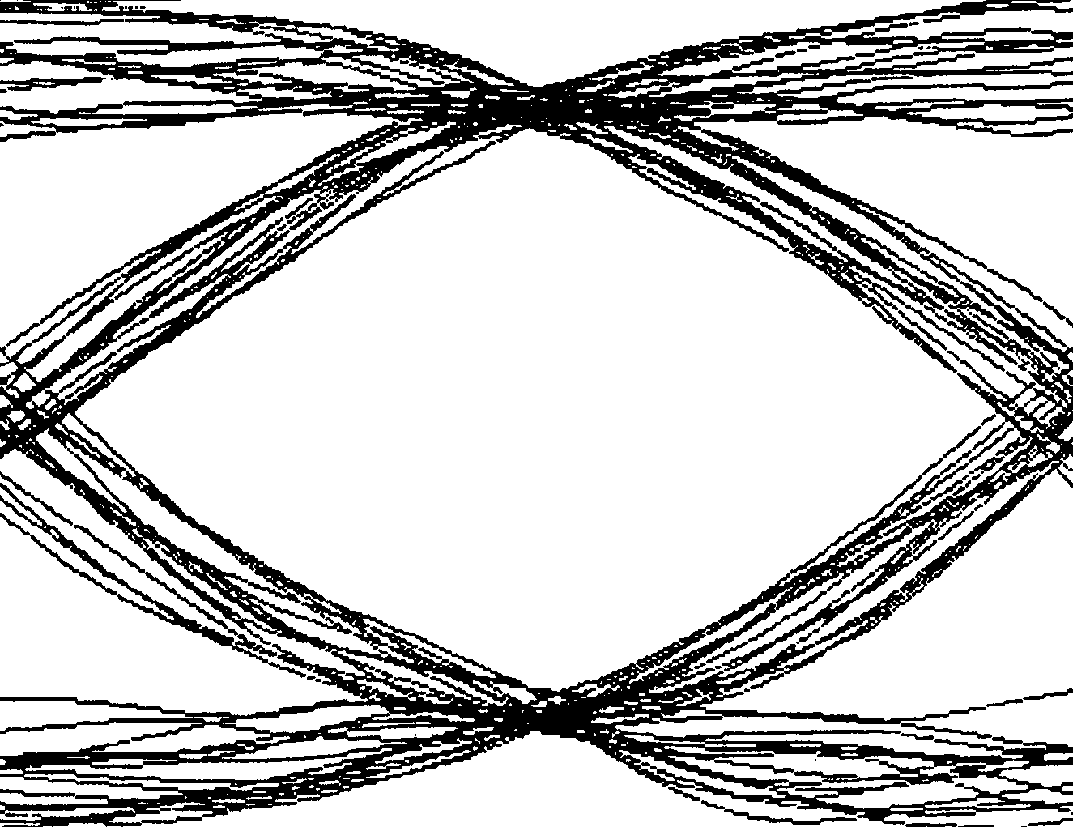
Hilbert Transform
Quadri-Correlator
Lower side-band selector
Complex Multiplier

Your Brain after this presentation:

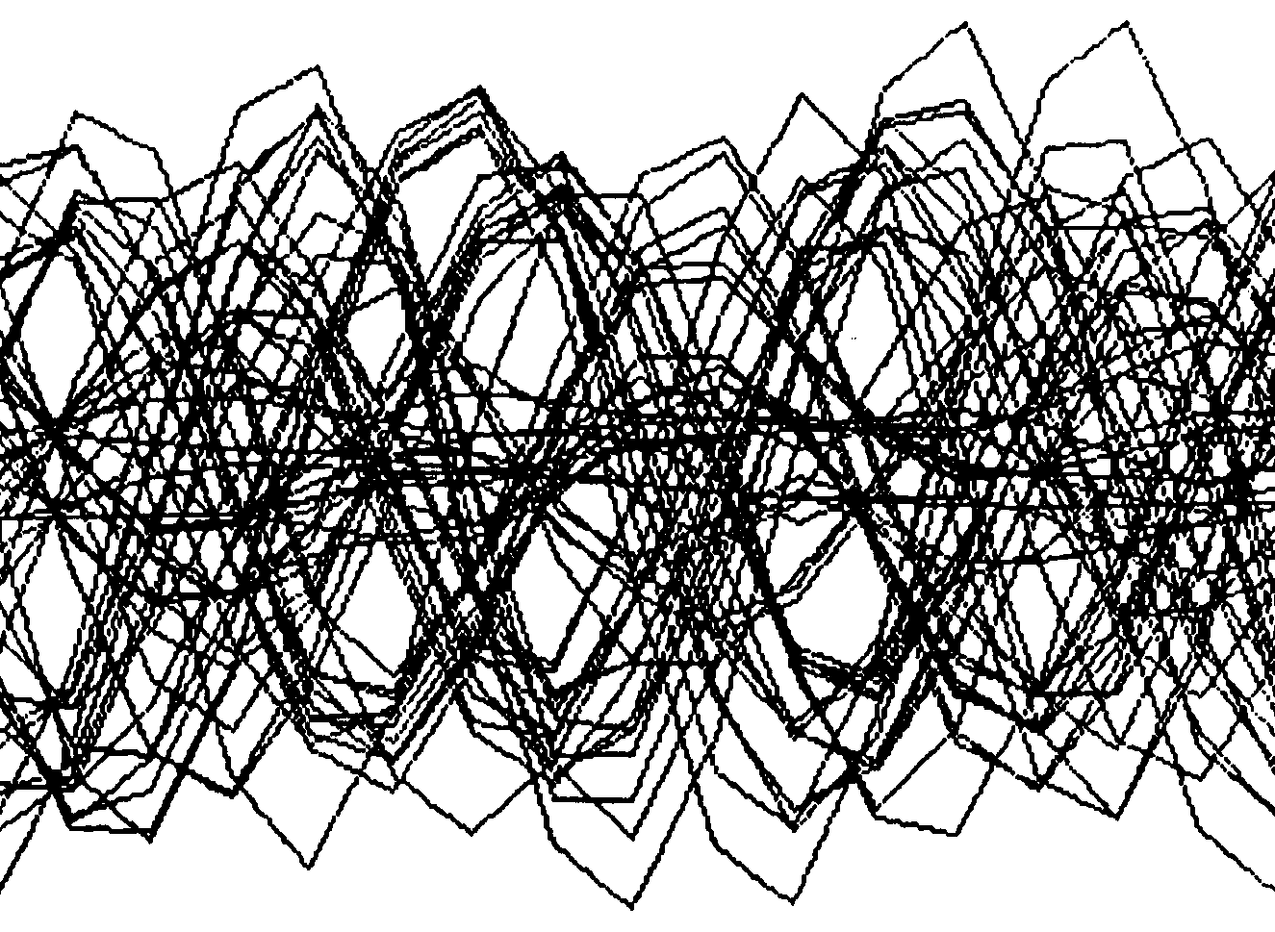
Hilbert Transform
Quadri-Correlator
Lower side-band selector
Complex Multiplier

