MASTERSONIC Power Supply
For Advanced Ultrasonic Systems

Traditional design barriers have finally been broken. All sonic and ultrasonic parameters are programmable. It is a triumph of merging digital and power electronics. There is no comparison to anything currently available in the world of Ultrasonics.

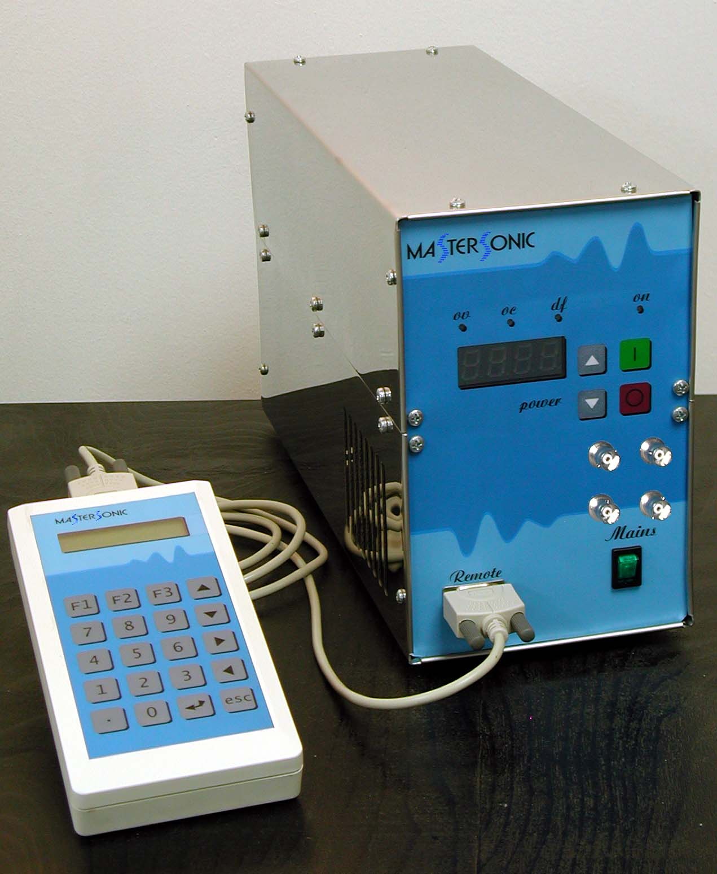 | Mastersonic MMM Power Supply (or sonic and ultrasonic generator) consists of two parts:  - Generator  - Remote control panel for parameterization.  The generator is a separate device and it can work independently from the remote control panel.

The picture to the right shows the generator front panel and the following indicator lights and function buttons.  Power Level Display:  The 4-digit LED display indicates the ultrasonic generator power level as a percentage of its nominal (maximum) power.  ON – Ultrasonic Power On/Off indicator:  This green light is illuminated when the generator is turned ON. When the generator is turned OFF this light is not illuminated.  OV - Over voltage indicator:  In a normal condition this light is not illuminated. When illuminated this red light indicates the auto- protection for over voltage is activated.  OC - Over current indicator:  In a normal condition this light is not illuminated. When illuminated this red diode indicates the auto-protection for maximal current is activated.  DF - Driver fault indicator:  In a normal condition this light is not illuminated. When illuminated this red diode indicates failure of voltage supplying drivers.  4 square function buttons:  Green for power ON, Red for power OFF, and 2 Gray buttons for increasing and decreasing the power.  Mains switch (bottom right): for turning the main power supply ON and OFF.  9 pin interface connector (bottom left): for remote control panel connection. | 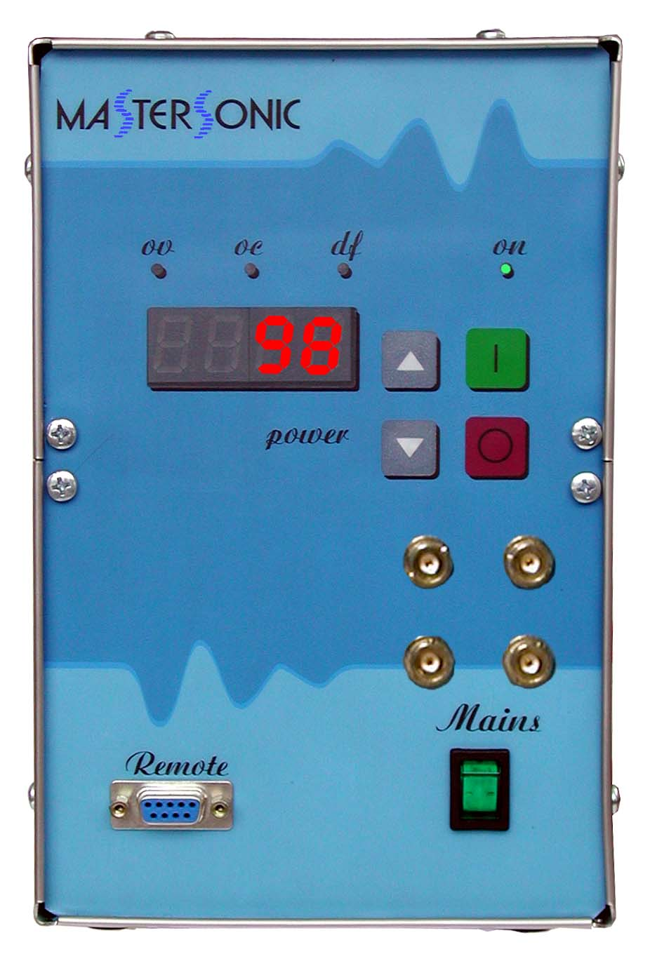  Front Panel
On the front panel of the generator four BNC connectors are mounted and they are for measure devices like oscilloscope, oscillograph, spectral annalizator which display the signals of ultrasonic generator.
The following signals can be displayed.

- The connector at the upper left side is for the signal of the gate driving of the power transistor.
- The connector at the upper right side is for the signal of the voltage over the transducer.
- The connector at the down left side is for the signal of the current through the transducer.
- The connector at the down right side is for the signals of PWM.

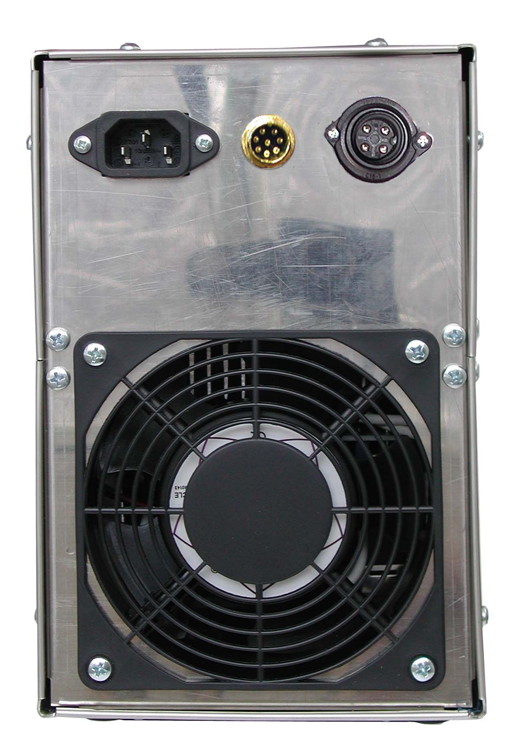 | The back panel of the ultrasonic generator has the following 3 connectors:  - Left - Main power supply connector, 230 VAC, single phase.  - Center - Connector for external ON or OFF power control (by controller or relay).  - Right – Transducer power connector.
Connector details for external ON/OFF power control.
NOTE: To operate the generator with the front panel ON/OFF buttons PIN1 and PIN2 should be connected. External connector must be in its place before starting the generator.
 | Power output connector for ultrasonic frequency. The drawing shows the connection from ultrasonic generator to the transducer.

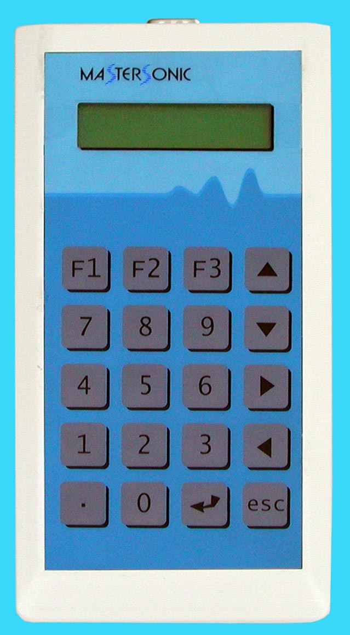
Remote control panel:
The remote control panel is designed for tuning the ultrasonic generator while connected to the oscillating mechanical system. The remote control panel may be connected to the front panel connector when the generator is turned ON or OFF. The remote control panel receives its power through the connector. When connected, the generator parameters that are in its memory are transferred to the buffer of the control panel.
The remote control panel has LCD display with 2 rows of 16 symbols and keyboard with 20 buttons, which has the following functions:
- Digital keyboard from 0 to 9 and decimal point – for entering new parameters.
- “ ” Enter button to input parameters or initiate a Function.
- “esc” button to escape or cancel current operation.
- Up and Down Arrow buttons for increasing and decreasing display values.
- Left and Right Arrow buttons for reading the LCD menu.
- Functions buttons:
F1 – reads stored parameter data. Press F1 then Select a memory position (0 to 20) to view stored parameters.
F2 – stores new parameter data from the buffer to a selected memory position (0 to 20).
F3 – downloads parameter data from the buffer to the generator memory.

NOTE: If the Mastersonic generator is ON when downloading data from the remote control panel the generator will turn OFF automatically for system safety. The generator may be restarted manually after the download is completed.

Description of Settings Displayed:

Reading data  <<<<<< | Upload the parameters from the generator  to the remote control panel buffer.
Sending data  >>>>>>> | Downloading parameters from the remote control panel buffer to the generator memory.
Read memory  Location xx | Reading parameters from a memory location (xx) to the remote control panel buffer.
Write memory  Location xx | Writing parameters from the remote control panel buffer to a memory location (xx).
Frequency  21.940kHz | The average frequency of the ultrasonic transducers (first, natural resonant mode).
Sweeping range  0-200kHz | Sweeping frequency interval of the ultrasonic cleaner.
Tracking range  1.000kHz | Not used.
Power  50% | The current power as a percent of nominal power of ultrasonic generator.
PWM period  1.190s | Period of PWM
PWM ratio  65% | Ratio of PWM

Accessory:

With the ultrasonic generator as optional, we offer a optoisilated adapter for connecting the generator to computer as the is standart RS232C.
The adapter is connected instead of remote control panel. The transfer protocol is semiduplex and the transfering of the data (riding/writing) is controlled by signalls RTS. The adapter is accompanied by programm for PC with RS232C port, working with operating system Windows ’98.
Usin the program can help controlling the ultrasonic generator.

The ultrasonic generator can read the following commands.

%01f(CR) – inquire for the current frequency of the generator.

Note: Each command is terminated with carriage return (CR) ASCII code HEX =“0D “ or decimal = 13

%01s(CR) – inquire for the current sweeping of the generator.

%01w(CR) – inquire for the current PWM period of the generator.

%01f(CR) – inquire for the current PWM ratio of the generator.

%03p(CR) – inquire for the current power of the generator.

After each inquiry the generator returns the message in the following format:

#02fxx.xxx(CR) - replay about the current frequency. Where xx.xxx is a number with two integers and 3 partial part of digit.
Example: #02f20.100(CR) - means the current frequency is equal to 20100Hz

#02sxx.xxx(CR) - replay about the current sweeping.
Example: #02s00.300(CR) means the current sweeping is equal to 300Hz

#02wxx.xxx(CR) - replay about the current PWM period.
Example: #02w00.100(CR) - means the current PWM period is equal to 0,100sec.
Note: The PWM period must be between 10sec and 10mSec

#02m00.xxx(CR) - replay about the current PWM ratio.
Example: #02m00.075(CR) - means the current PWM ratio is equal to 75%

#02p00.xxx(CR) - replay about the current power of generator.
Example: #02p00.085(CR) - means the current power is equal to 80% from nominal power.

The generator can also read the following commands:

Start command
@01start(CR)
Stop command
@01stop(CR)

The commands for setting new values of parameters are:

#01fxx.xxx(CR) – Setting the new operating frequency of the generator.

#01sxx.xxx(CR) – Setting the new sweeping of frequency.

#01wxx.xxx(CR) – Setting the new PWM period.

#01m00.xxx(CR) – Setting the new PWM ration

#03p00.xxx(CR) – – Setting the new operating power of the generator

The generator replay with a character ”<(CR)” after receiving the setting parameters. The answer is not controlled.

