MASTERSONIC Power Supply
– UltraSonic Filtration –

Traditional design barriers have finally been broken. All sonic and ultrasonic parameters are programmable. This product is a triumph of merging digital and power electronics. There is no comparison to anything currently available in the world of Ultrasonics.
Mastersonic MMM Power Supply (or sonic and ultrasonic multifrequency generator) consists of two main parts:
- Generator
- Remote Control Panel for parameterization.
- As an option, the Remote Control Panel can be replaced with an adapter for direct PC control.

The generator is a separate device and it can work independently from the Remote Control Panel.
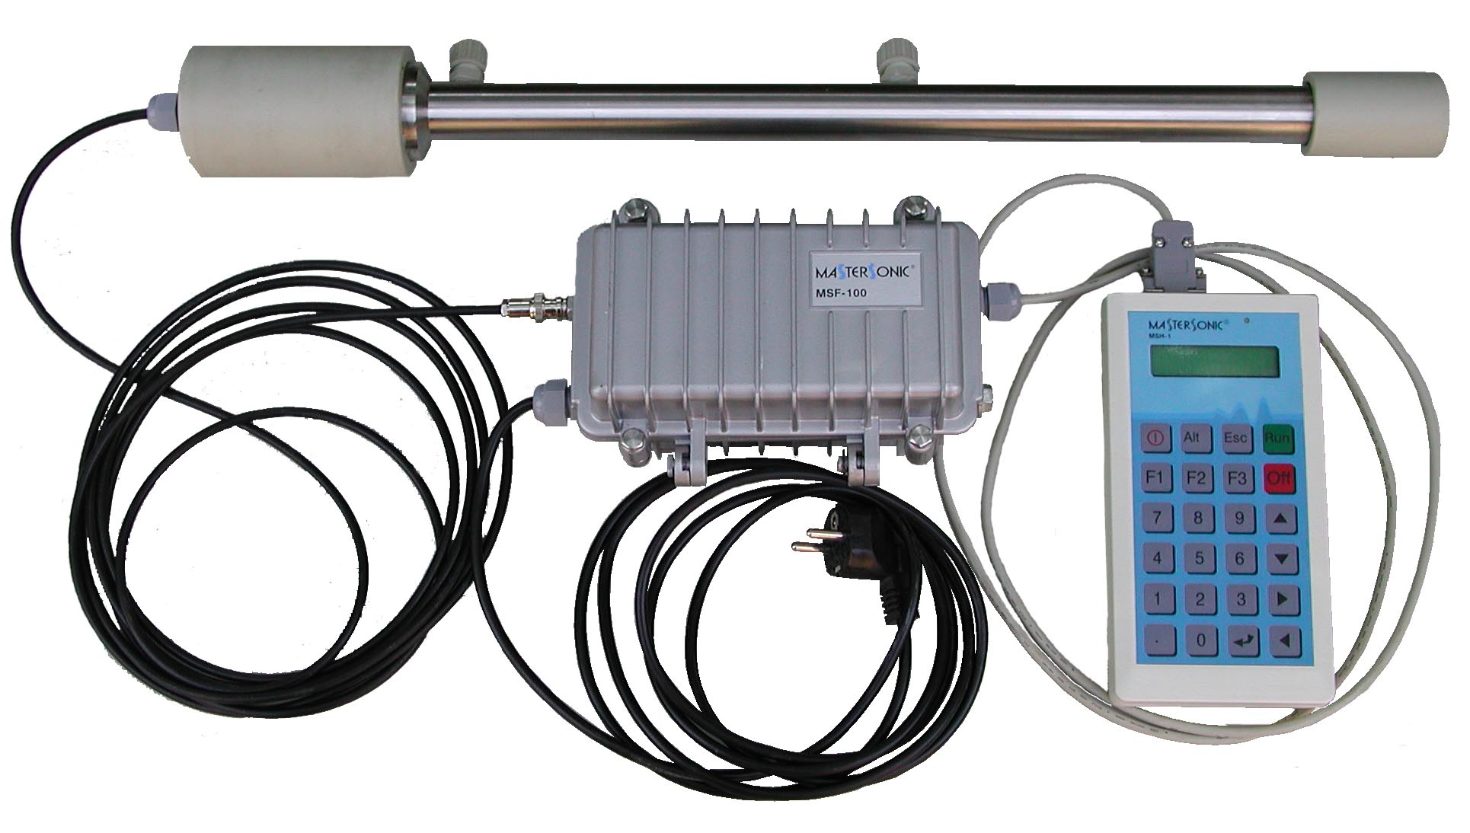

The generator main supply is realized through the mounted power supply cable – C230VA, single phase. (If it’s necessary the cable can be replaced with a longer one.)
On the left side of the power supply cable is the BNC connector – the high-frequency output for the ultrasonic transducer.
On the other side of the cabinet is the cable through which the Remote Control Panel or the PLC (like Simatic, Siemens) is connected to the generator.

The PLC connecting is made through 9-pins terminal cable, shown on the picture 2.
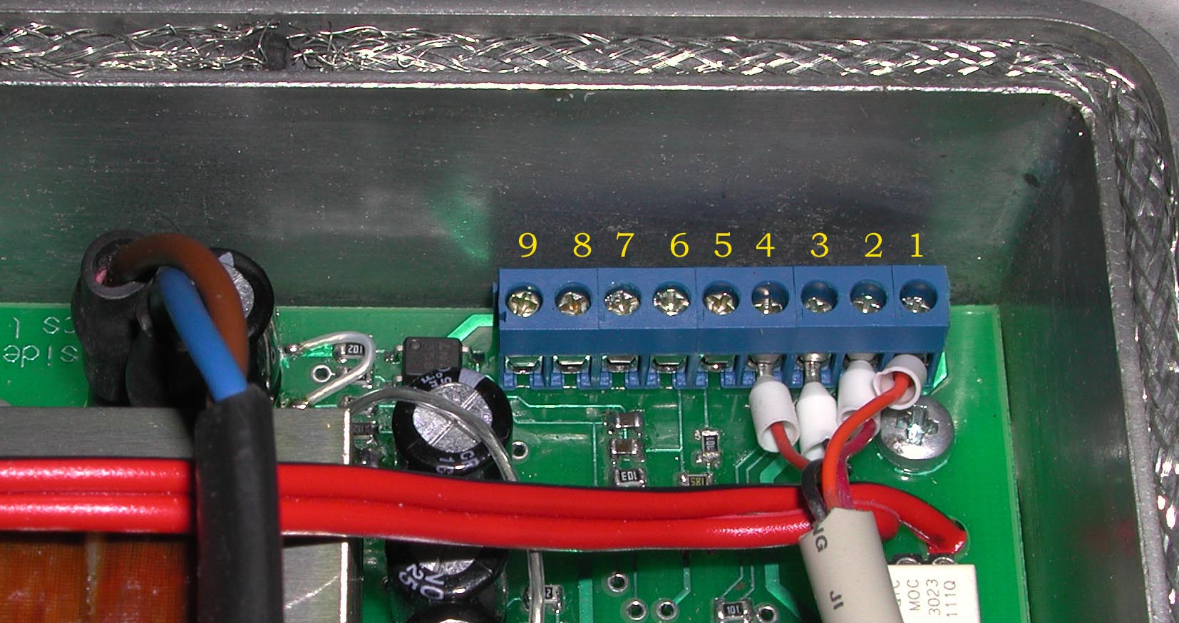
The Remote Control Panel connection should be made as shown on pictures 1,2,3,4.
Terminal 1 - +12V – orange
Terminal 2 - A – red
Terminal 3 - B – black
Terminal 4 - -12V – brown

ATTENTION: if the terminals are not connected correctly, this may cause a damage of the Remote Control Panel.

Analog setting of the power

If the terminals on pin 5 and pin 6 are connected to a potentiomer with value 2kΩ, as shown on the drawing, the power is set by it. If the potentiometer is not connected, the Remote Control Panel sets the power.

The external control of the generator is done through terminals on pins 7,8,9. The way of connecting is shown on the drawing. Through pins 7,8 the generator is switched on or off. When the terminals are closed the generator is switched on, and when the terminals are open, the generator is switched off.
NOTE: Terminals on pins 7,9 are protection inputs and they should be connected through short circuit enabling the generator to operate. If this circuit is open, the generator will stop operating.

Remote Control Panel:

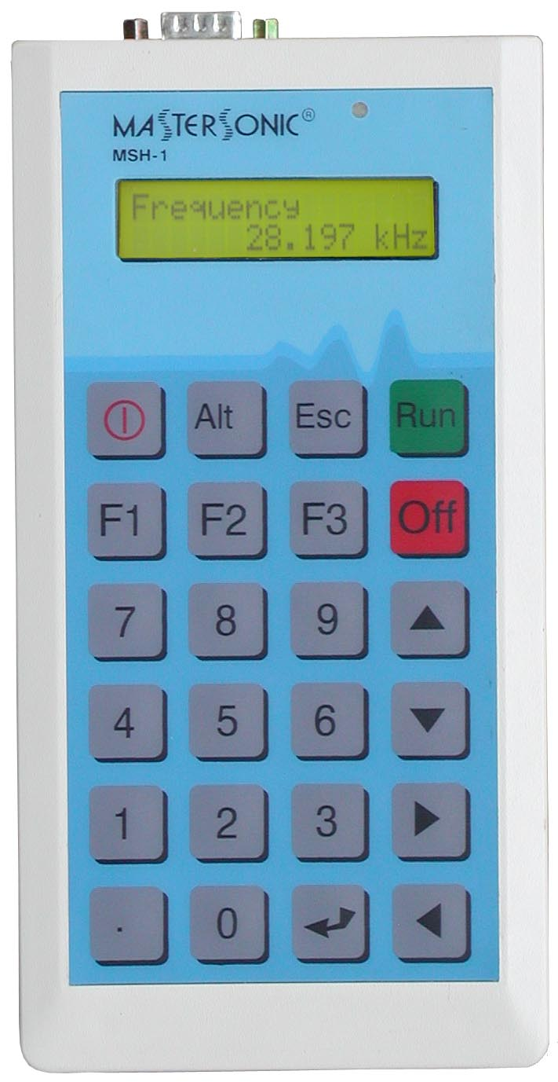
The Remote Control Panel is designed for tuning the ultrasonic generator while connected to the oscillating mechanical system. The Remote Control Panel may be connected to the front panel connector when the generator is turned ON or OFF. The Remote Control Panel receives its DC power through the connector. When connected, the generator parameters that are in its memory are transferred to the buffer of the control panel.
The Remote Control Panel has LCD display with 2 rows of 16 symbols and keyboard with 24 buttons, which has the following functions:
- Digital keyboard from 0 to 9 and decimal point – for entering new parameters.
- “ ” Enter button to input parameters or initiate a Function.
- “Esc” button to escape or cancel current operation.
- Up and Down Arrow buttons for increasing and decreasing display values.
- Left and Right Arrow buttons for reading the LCD menu.
- “Run” – “Off” buttons for start and stop process
- “Alt” Optional button for future applications
- “” Optional button for battery supply
- Functions buttons:
F1 – reads stored parameter data. Press F1 then Select a memory position (0 to 20), press “Enter” to load the parameters in to buffer.
F2 – stores new parameter data from the buffer to a selected memory position (0 to 20), press “Enter”.
F3 – downloads parameter data from the buffer to the generator memory.

NOTE: If the Mastersonic generator is ON, when downloading data from the Remote Control Panel the generator will turn OFF automatically for system safety. The generator may be restarted manually after the download is completed.

Description of Settings Displayed:

Reading data  <<<<<< | Upload the parameters from the generator to the Remote Control Panel buffer.
Sending data  >>>>>>> | Downloading parameters from the Remote Control Panel buffer to the generator memory.
Read memory  Location xx | Reading parameters from a memory location (xx) to the Remote Control Panel buffer.
Write memory  Location xx | Writing parameters from the Remote Control Panel buffer to a memory location (xx).
Frequency  21.080kHz | The average frequency of the ultrasonic transducers (first, natural resonant mode).
Sweeping range  0-1kHz | Sweeping frequency interval of the ultrasonic filter.
Power  50% | The current power as a percent of nominal power of ultrasonic generator.
PWM period  0.01s | Period of PWM
PWM ratio  65% | Ratio of PWM
Current  0,670 | Conditional load current

Accessory:

With the ultrasonic generator, as the option, we offer an opto-isolated RS232C adapter as the interface between the generator and a computer.
The RS232C adapter should be connected instead of Remote Control Panel. The transfer protocol is half-duplex, and the transfering of the data (reading/writing) is controlled by RTS signals. The adapter is accompanied by PC program for RS232C port (ONLY COM1), working with operating system Windows ’98 (for Windows ’95 and 2000 the program is still not tested).
Using the program can help controlling the ultrasonic generator with more options and more flexibility.

