SONIC-digital liquid processing performance: 2000 watt power supply

Amplitude / Power | Booster | Probe Percent Sub-merged | Circular Probe  25 mm diameter  120 mm length  Power Output | Circular Probe  38 mm diameter  125 mm length  Power Output | Circular Probe  50 mm diameter  125 mm length  Power Output
100 % | Titanium  1:2.5 | 50 % | 200 W | 640 W | 900 W
100 % | Titanium  1:2.5 | 90 % | 300 W | 780 W | 1200 W

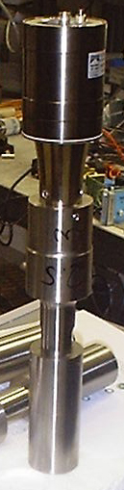
SONIC-digital Acoustic Stack

Transducer (3,000 W)

Best mounting Point

Booster (1:2.5)

Probe (50 mm)

