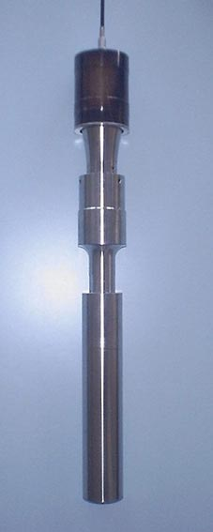
20 kHz Fixed frequency
2,000 watts max
Booster Ratio 1:2.5
Fullwave Probe (titanium)
Diameter = 50mm
Length = 250 mm

Power Draw Test: In Water

Amplitude at: 50% 100%
Full submerge: 1,000 W 1,500 W

¾ submerge: 1,000 W 1,500 W

½ Submerge: 1,000 W 1,500 W

¼ Submerge: 1,000 W 1,500 W

Notes:
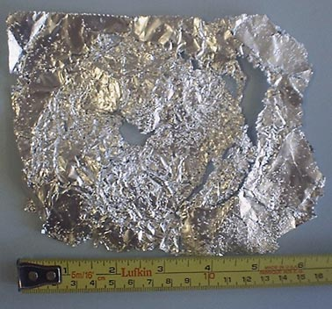
Good probe radial cavitation shown on sides by aluminum perforation test for 30 seconds.

Good probe radial cavitation shown on
bottom by aluminum perforation test
for 30 seconds.

Notes:
Good probe radial cavitation shown by visual inspection and by feel with hand submersion.

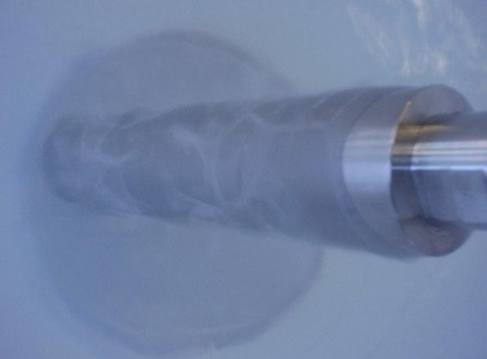
Probe in Water

Attached are some pictures and notes for your review. We took a standard fixed frequency generator and converter and tested with a high gain booster (ratio 1:2.5) and a full wave length titanium probe. The probe is about 250 mm (10 inches) in length and 50mm (2 inches) in diameter. Because of the larger diameter we are able to see excellent radial ultrasonic effects in addition to the axial effects on the probe tip. This may be an excellent tool for your testing.

As is normally done with ultrasonic baths to test for cavitation we did a quick foil test to see if cavitation would penetrate. The results were very good for a 30 second test. This was a slightly thicker foil than normally used so we feel good about the results.

We also see clearly the cavitation areas streaming of the side of the probe. When you immerse your hand in the water you can feel strong cavitation.

This option allows you some good flexibility:
1.) You can submerse the probe directly into the slurry from an inch up to 9 inches. (You must not submerse above the probe top, this will cause a system overload)
2.) We can deliver from low to very high concentrations of power with this system (300 to 1,500 watts). Your slurry is probably much denser than water so you will draw even more power. It’s possible that you should only set amplitude to 80% to keep power consumption and stress factors on such a high booster to an acceptable level.
3.) You can also change the booster to lower the amplitude (1:2.0 or 1:1.5) or remove the booster to test lower power and amplitude results.
4.) We can also discuss optional probe diameters after you have tested in your slurry. Smaller probes are possible but they will tend to give more axial and less radial energy. Larger probes become difficult to manage with an unknown liquid density so we need to be careful about larger probes. They may in fact require a special factory set-up that is different from what the 50 mm probe requires.

---------------

Comments from collaborators regarding applications:

The fundamental objective of my research is to find out if ultrasonic treatment can improve the mineral flotation process, which is widely employed in the mining industry. In order to establish the best mode of applying ultrasound energy in this process and thoroughly investigate the variables involved, I would like to experiment with as many scenarios as possible, including different frequencies, different power levels, different temperatures, with or without sweep and degassing actions, pre-treatment of the mineral slurry with ultrasound prior to actual flotation, applying ultrasound during flotation, etc. I will place the mineral slurry either directly into the ultrasonic bath or into a square-shaped, Plexiglas container and submerge the container into the bath, to see which one will be the most effective or whether that would make any difference. The latter would be convenient, since flotation will be carried out in the same Plexiglas container. If the slurry is placed directly into the ultrasonic bath, after treatment, it will be removed from it by vacuum suction, unless the bath has a drainage facility. During flotation, the slurry needs to be stirred vigorously, but during the ultrasonic treatment stage, stirring can be at a slow rate, just enough to keep the solid particles in suspension. Stirring will be accomplished by means of a variable-speed mechanical impeller, submerged into the slurry. As you have suggested, intermittent
(ON/OFF) stirring is also a possibility

I hope the above description further clarifies my needs, and I look forward to your quotations. I am not sure if you have an off-the-shelf unit that could be suitable for me, or if a unit has to be made specially.

