MASTERSONIC

Sonic & Ultrasonic Technology

The MASTERSONIC program represents a brand new approach in Sonic and Ultrasonic power supplies equipment.

The MASTERSONIC power supply equipment is based on the MMM Technology, which enables producing high efficiency active power in wide-band sonic and ultrasonic vibrations.

Wide-band sonic and ultrasonic energy (ranging in frequency from infrasonic up to the MHz domain) propagates through arbitrary shaped solid structures, heavy and very-thick-walls metal containers, pressurized reservoirs, very thick metal walls of autoclaves, etc. in many different mechanical structures and in liquids, such as ultrasonic cleaning systems. The secret to its application is a novel sonic / ultrasonic, multifrequency power supply (MMM Technology) that can initiate ringing and relaxing, modulated, multimode mechanical oscillations including harmonics and sub-harmonics. The system offers fine control and excellent repeatability from its programmable interface and produces high efficiency active power ranging from below 100 W up to many kW.

Multifrequency, Multimode, Modulated Sonic & Ultrasonic Vibrations (MMM Technology) can be excited in any heavy-duty conditions, producing pulse-repetitive, phase, frequency and amplitude-modulated bulk-wave-excitation covering and sweeping an extremely wide frequency band. Such sonic and ultrasonic driving creates uniform and homogenous distribution of acoustical activity on a surface and inside of the vibrating system, while avoiding the creation of stationary and standing waves, so that the whole vibrating system is fully agitated. Such multifrequency ultrasonic structural excitation is ideal for agitating arbitrary shaped liquid and solid masses at arbitrary distances and placed in open or pressurized vessels, containers, autoclaves, reservoirs and pipes, at any temperature, while maintaining optimum efficiency of electrical to acoustic energy transfer.

Fields of possible applications related to MMM Technology are: Advanced Ultrasonic Cleaning, Material Processing, Sonochemistry, Liquid Metals and Plastics treatment, Alloying, Casting, Molding, Injection, Extrusion, Ultrasonically Assisted Sintering, Liquids Atomization, Liquids Mixing and Homogenization, Materials Testing, Accelerated Aging and Stress Release, Plastic and Metals Welding, Metals Forming, Wires and Profiles Drawing, Cables Extrusion, Isolation, Coating etc.

In traditional ultrasonics technology, transducers have been designed to satisfy precise resonant conditions: In order to achieve maximal efficiency, all oscillating elements should operate on the same frequency. MMM technology can drive with high efficiency any complex mechanical system up to a mass of several tones, consisting of arbitrary resonating elements. MMM technology, instead of optimizing transducers to accept certain resonant frequency operation, optimizes the complex electrical driving (or signal shape) to be applicable to any specific oscillating structure, in a wide-band frequency domain, allowing mechanical designers to optimize their mechanical structures without limits.

MMM TECHNOLOGY

All traditional sonic and ultrasonic actuators or transducers oscillate in a kind of simple or mixed, constant-frequency contraction-extension vibration mode. This usual mode of oscillations can be described when one or more, axial, lateral or any other space dimension of transducer is periodically changing length, following some simple sinusoidal function. Briefly, we can say that all conventional sonic and ultrasonic sources used in industrial, material processing, moderate and high power applications require as input an oscillating electrical signal, and produce as output an oscillating mechanical contraction / extension of proportional amplitude. The frequency may be relatively constant, varying just enough to compensate for temperature and load changes, or sometimes sweeps a narrow frequency band around a central operating frequency.

In contrast the high power Multifrequency, Multimode, Modulated Sonic & Ultrasonic system generates multimode mechanical oscillations in a mechanical system over a very wide frequency range.

Every elastic mechanical system has many vibration modes, plus harmonics and sub harmonics, both in low and ultrasonic frequency domains. Many of these vibrating modes are acoustically and/or mechanically coupled; others are relatively independent. The multimode sonic and ultrasonic excitation described here has the potential to synchronously excite many vibrating modes in solids and liquids (including harmonics and sub harmonics), producing high intensity vibrations that are uniform, homogenous and repeatable.

The oscillations of here-described sonic and ultrasonic source are not random - rather they follow a consistent pulse-repetitive pattern, being in the same time frequency, phase and amplitude-modulated by the control system. This avoids the creation of stationary or standing waves (typically produced by traditional ultrasonic systems operating at a single frequency) that generate regions of high and low acoustic activity. MMM technology provides great freedom of control, regulation and programming over all vibration, frequency and power parameters.

Ultrasonic Cleaning, Liquid Processing and all aspects of Sonochemistry, Plastic Industry and Metallurgy can benefit immensely from using Multifrequency, Multimode, Modulated Sonic & Ultrasonic Sources.

MMM Technology for Ultrasonic Cleaning
Generations ahead!
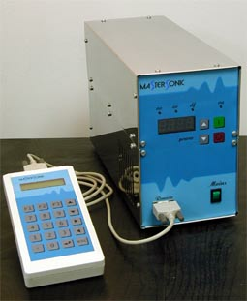
Multifrequency, Multimode, Modulated
Sonic & Ultrasonic technology.
No other manufacturer has yet achieved and matched MMM exciting standards in precision cleaning. MMM is not only more efficient and effective than any other ultrasonic cleaning technology, it is UNIQUE.
Seeing is the believing! Try the aluminum foil test for yourself! Place the foil sample into our ultrasonic bath and hold the foil for approx. 5 - 10 seconds and you'll discover why there's simply no comparison with any other conventional ultrasonic cleaning machine!
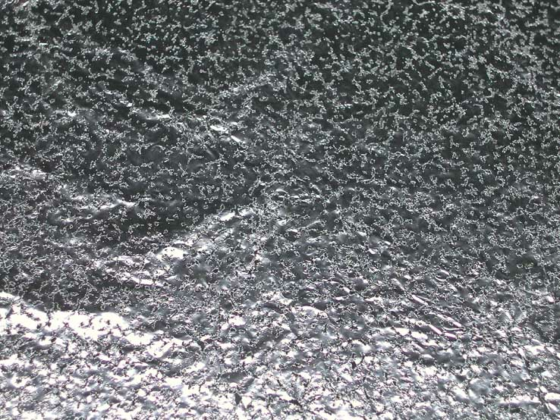
Perfectly, uniformly perforated aluminum foil, after 5 to 10 seconds of exposure to MMM ultrasonic vibrations in a ultrasonic cleaner

Frequency Range: From Hz to MHz; From Infrasonic to Supersonic

This new technology provides:
- Superior and deep penetration, independent of water levels.
- Reliability with extra power spread throughout the bath.
- Even distribution of ultrasonic energy throughout the liquid gives uniform and thorough cleaning of the surface without the risk of damage to fine parts and sensitive instrument.
- Extremely efficient electronics and transducer coupling to ultrasonic bath (overall approx. 95% efficiency) eliminates or reduces the additional need for heating.
- Spatial distribution of ultrasonic activity inside of a cleaning liquid is homogenous (no dead zones, no standing waves, fast and large frequency sweeping, broadband spectrum, complex modulation).
- Cleaning solvents, detergents and additives can be significantly reduced, or even eliminated because of the very high cleaning activity of the acoustic broadband spectrum.
- Cleaning time can be several times shorter comparing to traditional ultrasonic cleaning technology.
- Fast liquid conditioning and degassing because of very large regulating zone between maximal and average ultrasonic power and because of the ability to switch instantaneously between acoustic spectrums.
- Smooth Ultrasonic, PWM-power regulation from 1% to 100%. Ultrasonic energy can be easily adjusted in order to clean very fine and sensitive parts without damaging them.
- Fast and automatic ultrasonic-power and high-activity recovery after liquid mixing and after introducing ultrasonic load (after introducing parts to be cleaned).
- Cavitation level can be smoothly controlled from very low to very high (by changing signal-processing parameters of MMM generator).
- Ultrasonic erosion and mechanical damages to cleaning baths and vessels, as well as on the parts under cleaning is significantly reduced (compared to traditional technology) because of uniform distribution of ultrasonic activity.
- MMM Ultrasonic Power Supplies can drive any traditional piezoelectric transducer/s, using less energy and producing superior cleaning effects, comparing them to traditional, single frequency, and frequency sweeping Power Supplies.
- Several levels of overload/s protection are implemented.

Until now, conventional ultrasonic cleaning baths have been very power hungry and power inefficient, only about 5-25%. Larger industrial units could become power hungry monsters, making the unit not only inefficient but also ineffective. Often as a last resort, heaters are used to "assist" cleaning.
There have been conventional “sweep frequency” ultrasonic cleaners but still based on "fixed frequency" and narrow frequency interval sweeping, with a slightly faster response time. "Fixed frequency" is more suitable to work in pre-determined conditions e.g. in ultrasonic welding of plastic parts.
Conventional fixed/single frequency operation results in "standing waves" being set up in the cleaning bath. A direct consequence of these standing waves is that cleaning is patchy across the surface being cleaned. Thus, some areas are excessively cleaned while other left unaffected. It also makes the effectiveness of conventional ultrasonic cleaner very variable and subjective to fluid level, fluid temperature and load conditions.
Using our state-of-the-art MMM technology, these "standing waves" do not exist and the efficiency goes well up!

MP Interconsulting
Miodrag Prokic
Marais 36
CH 2400, Le Locle
Switzerland
+41-32-9314045
mpi@bluewin.ch
http://www.mpi.powerultrasonics.com/
http://ultrasonic-products.tripod.com
MASTERSONIC in Plastic Industry and Metallurgy

By introducing ultrasonic vibrations into molten plastic or metal (for instance by vibrating casting mold, extruder body, or directly agitating liquid mass in continuous or static casting), almost any kind of high density composite plastic, or metal alloy can be processed much more easily and faster, compared to existing, traditionally known technologies, because ultrasonic vibrations would remove friction, make perfect mass homogenization, degassing, fine microcrystallization, stimulate diffusion and heat transfer in the mass, make excellent atomization and coating, injection, remove porosity and voids during the solidification phase of castings, etc.

Ultrasonically treated metals in the phase of solidification are presenting excellent overall properties (after solidification), much better than the same metals produced traditionally. Many new, exotic and naturally impossible metal mixtures and alloys can be realized in Ultrasonic Metallurgy.

In the cable industry, ultrasonically we can realize high quality wires and cables isolation, excellent plastic coating, perfect homogeneity and fluidity of plastic materials during extrusion… We can also use new and advanced plastic materials, not applicable in traditional technology etc.

In wires, cables, metal profiles drawing and forming, we can apply ultrasonic vibrations and optimize any traditional technology in that field, extend the number of different metals and alloys for wires production, produce number of profiles impossible to be realized by traditional drawing techniques, etc.

MP Interconsulting
Miodrag Prokic
Marais 36
CH 2400, Le Locle
Switzerland
+41-32-9314045
mpi@bluewin.ch
http://www.mpi.powerultrasonics.com/
http://ultrasonic-products.tripod.com

MMM-Signal Processing Examples

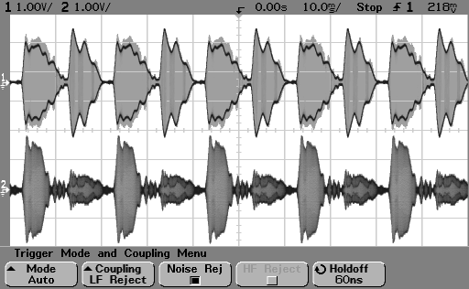

One of possible modulated load voltage and current shapes measured on the load (Only low frequency multiple-modulated signals are presented)

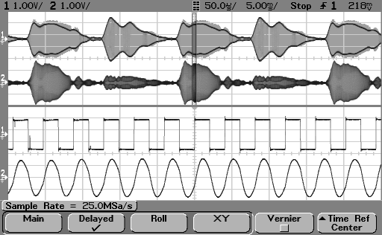

Modulated load current and voltage shapes measured on the converter:
Upper: Modulated Voltage and Current signals in low frequency domain
Lower: Carrier Voltage and Current ultrasonic frequency signals
(Complex modulation of the carrier signal is not visible)

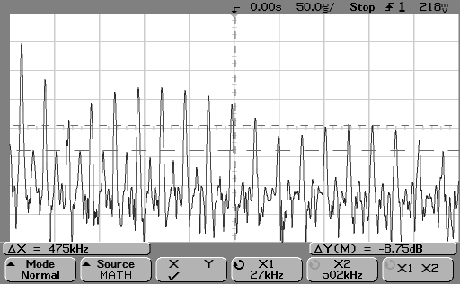
Movable, floating and sweeping spectrum of the load current

MP Interconsulting
Miodrag Prokic
Marais 36
CH 2400, Le Locle
Switzerland
+41-32-9314045
mpi@bluewin.ch
http://www.mpi.powerultrasonics.com/
http://ultrasonic-products.tripod.com
Applications:

Ultrasonically Assisted Plastic Extrusion

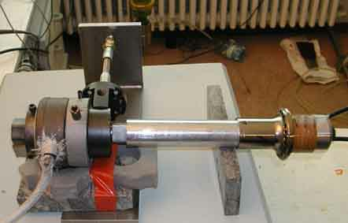

Ultrasonic converter

Wave-guide
Extruder

Ultrasonically agitated plastic extruder for composite plastics

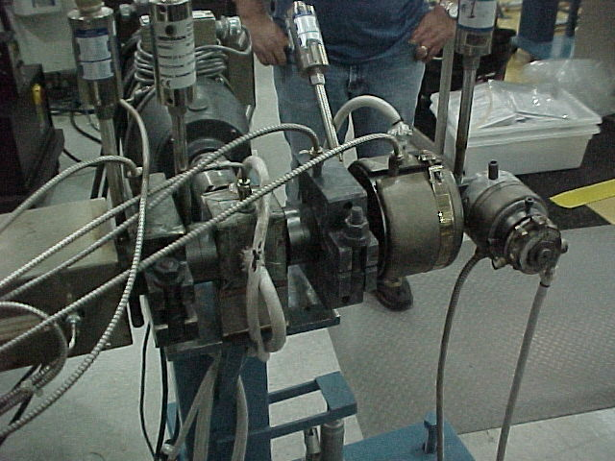

Extruder

Extruder in the production line
Cleaning in Supercritical, Liquid Carbon Dioxide

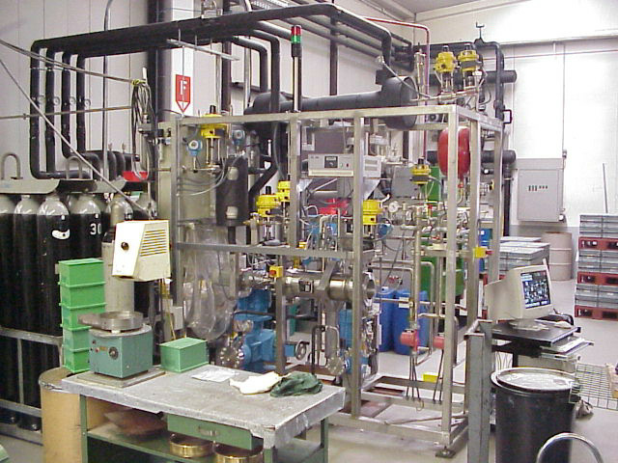

Cleaning Station in Supercritical, Liquid Carbon Dioxide
Ultrasonic
Reactor

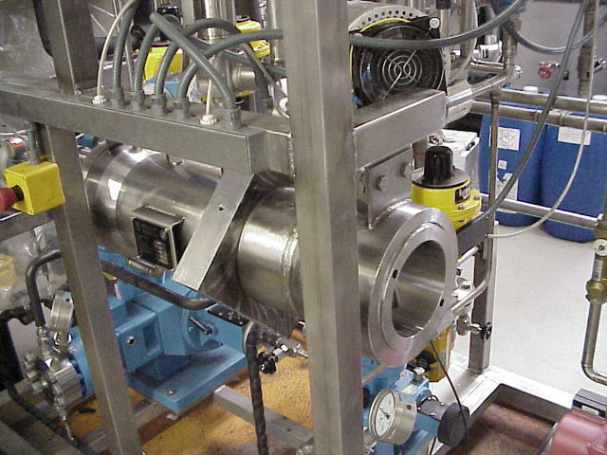
Pressurized Ultrasonic reactor agitated with Mastersonic Power Supply (visible only autoclave for liquid CO-2)

